Name: _____________________________________

SOCY2200 Statistics Instructor: Natasha Sarkisian
Multiple Choice Test 4

1. If a correlation coefficient for X and Y is 0.2, we can calculate that:
- 2% of variance is shared between X and Y
- 2% of variance in Y is unique
- 20% of variance is shared between X and Y
- 20% of variance in Y is unique
- 4% of variance is shared between X and Y

2. The following graph shows the data corresponding to a:
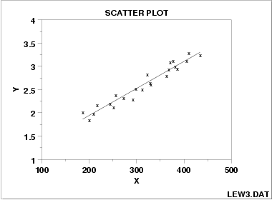
- strong positive correlation
- strong negative correlation
- weak positive correlation
- weak negative correlation
- perfect positive correlation

3. Which of the following can be a problem for a regression model?
- Interpolation
- A low standard error of estimate
- Severely skewed variables
- A lack of intercept
- A directional research hypothesis

4. If job satisfaction is the dependent variable, job demands is an independent variable, and the slope of a regression line b=-2:
- when job satisfaction increases by 1, job demands will decrease by 2
- when job satisfaction increases by 1, job demands will increase by 2
- when job demands increase by 1, job satisfaction will increase by 2
- when job demands increase by 1, job satisfaction will decrease by 2
- when job satisfaction decreases by 1, job demands will decrease by 2

5. If it turned out that the correlation between X and Y is due to the fact that W causes both X and Y, that correlation is:
- not statistically significant
- not practically significant
- causal
- directional
- spurious

6. For the data presented in the following graph, the most appropriate analytic approach would be:
- construct a scatterplot with a regression line to describe that relationship
- conduct a correlation analysis to assess the strength of that relationship
- conduct a bivariate regression analysis to assess the strength of that relationship
- calculate a coefficient of determination (R-squared)
- construct a lowess plot to describe that relationship
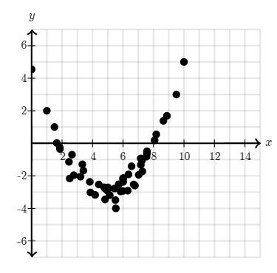
7. Which pair of variables is appropriate for Pearson’s correlation coefficient?
- Religious affiliation and political party affiliation
- Religious affiliation and years of education
- Age and years of education
- Age and marital status
- Race and political party affiliation

8. When regressing Y on X, the predicted values:
- Are always equal to actual values of Y
- Are always equal to actual values of X
- Can be calculated for any value of X
- Only can be calculated if we first calculate the error, e
- Are used to calculate the regression coefficients a and b

9. In the post-hoc analysis after a chi-square test, we use:
- Adjusted residuals
- Weights
- Effect size calculations
- Degrees of freedom
- Pairwise t-tests

10. The expected frequencies in chi-square test calculations show what the distribution would look like if:
- The two variables would be related
- The two variables would be independent
- Y would be dependent on X
- The observed frequencies would be independent
- We rejected the null hypothesis

