SOCY2200 Statistics Instructor: Natasha Sarkisian

Worksheet Week 7: Opinion Polls and Hypothesis Writing

Create a word document with your answers and submit it on Canvas.

1. Write a null hypothesis and two versions of research hypothesis – non-directional and directional (pick whatever direction you think would be more likely to exist):
- What is the relationship between a university’s prestige and students’ mental health?
- Do men’s views about gender ​roles (traditional vs liberal) differ depending on their age?
- Do Whites and African Americans differ in the amount of time they spend with their relatives?

2. Write a null hypothesis corresponding to each of the five research hypotheses used in the study described here:
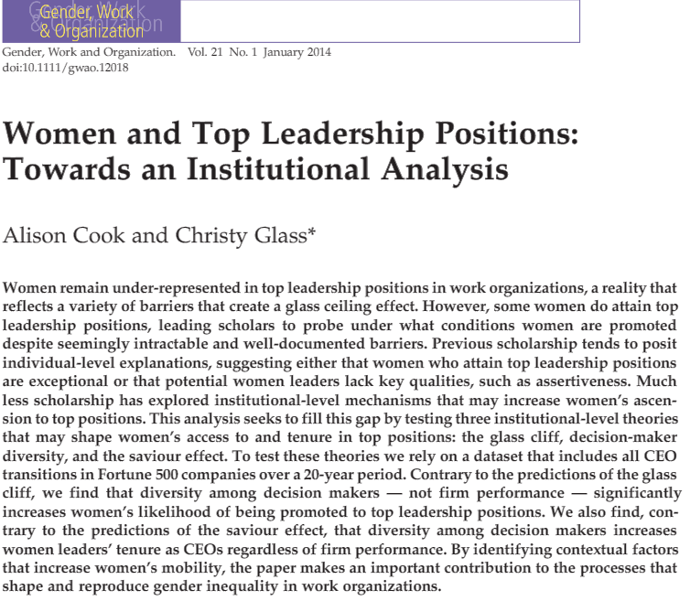

Glass Cliffs
“Recent theoretical innovations in the literature on gender and organizational mobility have identified the so-called glass cliff, a metaphor to describe a phenomenon whereby women are more likely than men to be appointed to top leadership positions in organizations that are struggling, in crisis and/or at risk to fail.”
H1: Women are more likely than men to be appointed CEO in firms experiencing declining growth.

The Saviour Effect
“While analysis of the glass cliff focuses on processes that increase women’s likelihood of being promoted, the saviour effect considers the mechanisms that shape their post-promotion tenure. The saviour effect predicts that women will be granted less of an opportunity to prove their leadership capabilities compared to men, leading to significantly shorter tenures. In addition, women CEOs of firms experiencing declining growth are likely to be replaced by more traditional leaders — men —who will be brought in to ‘save’ the firm from poor leadership.”
H2a: Women CEOs will enjoy shorter average tenures than men CEOs.
H2b: Women CEOs of poorly performing firms will be more likely than men CEOs of poorly performing firms to be replaced.

Institutional Diversity
“A great deal of empirical evidence suggests that gender bias and in-group preferences shape hiring and promotion decisions in ways that tend to limit the occupational mobility of women.”
H3a: Gender diversity among boards of directors will increase the likelihood that a woman will be appointed CEO.
H3b: Women CEOs will enjoy longer tenures in firms with diverse boards of directors compared to women CEOs in firms without diverse boards of directors.

- Visit https://www.natesilver.net/p/trump-approval-ratings-nate-silver-bulletin, find the Presidential Approval results from Rasmussen Reports, 10/1-10/7, 2025, and also read Silver Bulletin description of their methodology for their summary chart. Then read Rasmussen’s description of their methodology https://www.rasmussenreports.com/public_content/about_us/methodology
- Write a paragraph about that poll. You should make sure to address the following:
- its key results with regard to presidential approval
- who the respondents were (all adults, likely voters, registered voters, etc.)
- what the sample size was
- how that sample was selected (is it a random/probability sample?)
- any information on nonresponse
- how the data were collected (phone? internet?)
- calculate and report the maximum margin of error for this poll
- what the influence column tells us about this poll
- what grade Rasmussen received from Nate Silver’s site for their election polls (see https://www.natesilver.net/p/pollster-ratings-silver-bulletin)
- why you think they might have received that rating
- what kind of bias did Rasmussen have on average in their election tracking polls?

(b)Focus on one result of that poll -- percentage approve of Trump -- and construct, formally state (with a probability statement) and interpret the confidence interval for that specific proportion.

