SOCY7706: Longitudinal Data Analysis
Instructor: Natasha Sarkisian

Missing Data in Longitudinal Studies

In most datasets (not only longitudinal ones), we will encounter the issue of missing data. In cross-sectional datasets, it stems from the problem of item non-response -- for various reasons, respondents often leave particular items blank on questionnaires or decline to give any response during interviews. Sometimes the portion of such missing data can be quite sizeable. This is a serious problem, and the more data points are missing in a dataset, the more likely it is that you will need to address the problem of incomplete cases.

Types of missing data
The most appropriate way to handle missing or incomplete data will depend upon how data points became missing. Little and Rubin (1987) define three unique types of missing data mechanisms.

Missing Completely at Random (MCAR):
MCAR data exists when missing values are randomly distributed across all observations. In this case, observations with complete data are indistinguishable from those with incomplete data. That is, whether the data point on Y is missing is not at all related to the value of Y or to the values of any Xs in that dataset. E.g. if you are asking people their weight in a survey, some people might fail to respond for no good reason – i.e. their nonresponse is in no way related to what their actual weight is, and is also not related to anything else we might be measuring.

MCAR missing data often exists because investigators randomly assign research participants to complete only some portions of a survey instrument – GSS does that a lot, asking respondents various subsets of questions. MCAR can be confirmed by dividing respondents into those with and without missing data, then using t-tests of mean differences on income, age, gender, and other key variables to establish that the two groups do not differ significantly. But in real life, MCAR assumption is too stringent for most situations other than such random assignment.

Missing at Random (MAR):
MAR data exist when the observations with incomplete data differ from those with complete data, but the pattern of data missingness on Y can be predicted from other variables in the dataset (Xs) and beyond that bears no relationship to Y itself – i.e., whatever nonrandom processes existed in generating the missing data on Y can be explained by the rest of the variables in the dataset. MAR assumes that the actual variables where data are missing are not the cause of the incomplete data -- instead, the cause of the missing data is due to some other factor that we also measured. E.g., one sex may be less likely to disclose its weight.

MAR is much more common than MCAR. MAR data are assumed by most methods of dealing with missing data. It is often but not always tenable. Importantly, the more relevant and related predictors we can include in statistical models, the more likely it is that the MAR assumption will be met. Sometimes, if the data that we already have are not sufficient to make our data MAR, we can try to introduce external data as well – e.g., estimating income based on Census block data associated with the address of the respondent.

If we can assume that data are MAR, the best methods to deal with the missing data issue are multiple imputation and raw maximum likelihood methods. Together, MAR and MCAR are called ignorable missing data patterns, although that’s not quite correct as sophisticated methods are still typically necessary to deal with them.

Not Missing at Random (NMAR or nonignorable):
The pattern of data missingness is non-random and it is not predictable from other variables in the dataset. NMAR data arise due to the data missingness pattern being explainable only by the very variable(s) on which the data are missing. E.g., heavy (or light) people may be less likely to disclose their weight. NMAR data are also sometimes described as having selection bias. NMAR data are difficult to deal with, but sometimes that’s unavoidable; if the data are NMAR, we need to model the missing-data mechanism. Two approaches used for that are selection models and pattern mixture; however, we will not deal with them here.

Data Screening: Examining Patterns of Missing Data

It is a good idea to look at both the data and the codebook and/or questionnaire. I will use an example from GSS 2012 dataset:

. use https://www.sarkisian.net/socy7706/gss2012.dta

When examining missing data, the first thing is to make sure you know how the missing data were coded and take such codes into account when you do any recoding. It is also important to distinguish two main types of missing data – sometimes questions are not applicable and therefore not asked, but in other situations, questions are asked but not answered. It is very important to distinguish not applicable cases because those often would be cases that you might not want to include in the analyses or sometimes you might want to assign a certain value to them (e.g. if someone is not employed, their hours of work might be missing because that question was not relevant, but in fact we do know that it should be zero. Sometimes, however, datasets code some cases “not applicable” because a respondent has refused to answer some prior case – although coded not applicable, these cases are more likely to be an equivalent of “not answered” – i.e. truly missing data. “Don’t know” is often a tough category – sometimes, on ordinal scales measuring opinions, you might be able to place them as the middle category, but in other situations, it becomes missing data.

For example, in our GSS2012 data, for the agekdbrn variable, some people refused to answer that question while many others were not applicable because they don’t have children. We can see that in the questionnaire:
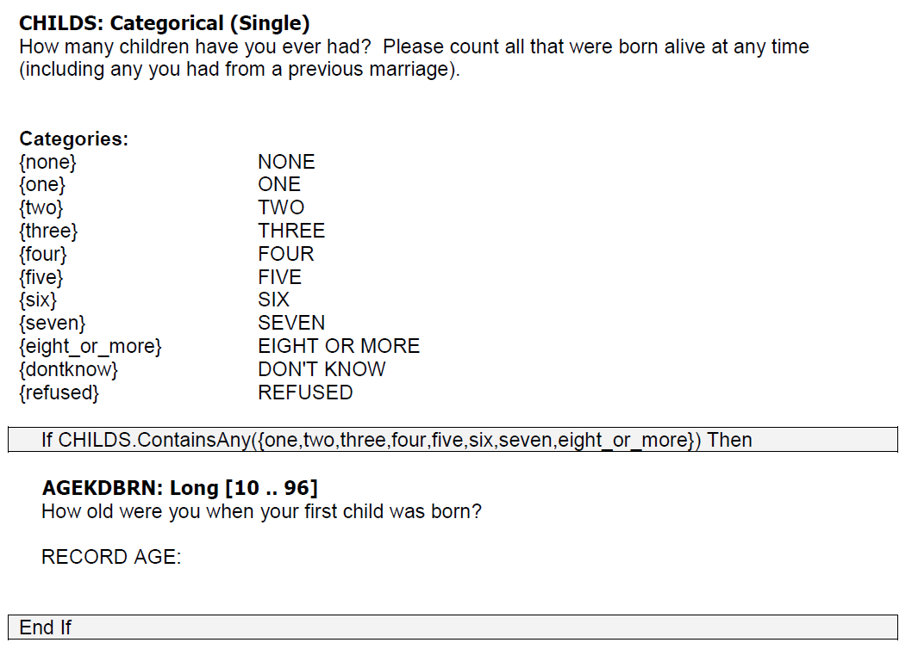
Let’s check that in the data:

. tab agekdbrn if childs==0
no observations

. tab agekdbrn if childs>0 & childs<., m

R'S AGE |
WHEN 1ST |
CHILD BORN | Freq. Percent Cum.
------------+-----------------------------------
13 | 1 0.07 0.07
14 | 7 0.49 0.56
15 | 20 1.39 1.95
16 | 30 2.09 4.04
17 | 68 4.74 8.78
18 | 101 7.04 15.82
19 | 102 7.11 22.93
20 | 110 7.67 30.59
21 | 134 9.34 39.93
22 | 78 5.44 45.37
23 | 95 6.62 51.99
24 | 82 5.71 57.70
25 | 94 6.55 64.25
26 | 70 4.88 69.13
27 | 78 5.44 74.56
28 | 58 4.04 78.61
29 | 52 3.62 82.23
30 | 55 3.83 86.06
31 | 32 2.23 88.29
32 | 32 2.23 90.52
33 | 28 1.95 92.47
34 | 29 2.02 94.49
35 | 21 1.46 95.96
36 | 13 0.91 96.86
37 | 11 0.77 97.63
38 | 10 0.70 98.33
39 | 7 0.49 98.82
40 | 6 0.42 99.23
41 | 3 0.21 99.44
42 | 1 0.07 99.51
46 | 1 0.07 99.58
50 | 1 0.07 99.65
. | 5 0.35 100.00
------------+-----------------------------------
Total | 1,435 100.00

. tab agekdbrn if childs==.
no observations

Let’s create a new variable that will distinguish true missing from skip pattern missing values:

. gen agekdbrn_n=agekdbrn
(544 missing values generated)

. replace agekdbrn_n=.n if childs==0
(536 real changes made, 536 to missing)

We will also look at a measure of individual health: there seem to be two variables, health and health1, both have quite a few missing values. Let’s crosstab them and then create a combined variable:

. tab health health1, m

CONDITION | RS HEALTH IN GENERAL
OF HEALTH | Excellent Very good Good Fair Poor . | Total
-----------+------------------------------------------------------------------+----------
excellent | 140 31 1 3 0 175 | 350
good | 6 103 179 6 0 304 | 598
fair | 1 8 28 90 2 146 | 275
poor | 0 0 0 7 27 49 | 83
. | 107 204 207 104 36 10 | 668
-----------+------------------------------------------------------------------+----------
Total | 254 346 415 210 65 684 | 1,974

. clonevar healthall=health
(668 missing values generated)

. replace healthall=1 if health1==1 & health==.
(107 real changes made)

. replace healthall=2 if (health1==2 | health1==3) & health==.
(411 real changes made)

. replace healthall=3 if health1==4 & health==.
(104 real changes made)

. replace healthall=4 if health1==5 & health==.
(36 real changes made)

. tab healthall, m

CONDITION |
OF HEALTH | Freq. Percent Cum.
------------+-----------------------------------
excellent | 457 23.15 23.15
good | 1,009 51.11 74.27
fair | 379 19.20 93.47
poor | 119 6.03 99.49
. | 10 0.51 100.00
------------+-----------------------------------
Total | 1,974 100.00

Once you differentiated between truly missing data and the results of skip patterns, you should examine patterns of missing data. We will use the rest of the variables from our example model for agekdbrn except I will substitute hhrace instead of race (that’s household race variable that actually has missing data) and add health variable.

. misstable summarize agekdbrn_n educ sex age born marital sibs hhrace healthall, all showzeros
Obs<.
+------------------------------
| | Unique
Variable | Obs=. Obs>. Obs<. | values Min Max
-------------+--------------------------------+------------------------------
agekdbrn_n | 8 536 1,430 | 32 13 50
educ | 2 0 1,972 | 21 0 20
sex | 0 0 1,974 | 2 1 2
age | 5 0 1,969 | 72 18 89
born | 3 0 1,971 | 2 1 2
marital | 0 0 1,974 | 5 1 5
sibs | 3 0 1,971 | 23 0 30
hhrace | 5 0 1,969 | 5 1 5
healthall | 10 0 1,964 | 4 1 4
-----------------------------------------------------------------------------

. misstable patterns agekdbrn_n educ sex age born marital sibs hhrace healthall, freq exok asis

Missing-value patterns
(1 means complete)

| Pattern
Frequency | 1 2 3 4 5 6 7
------------+------------------------
1,943 | 1 1 1 1 1 1 1
|
8 | 1 1 1 1 1 1 0
6 | 0 1 1 1 1 1 1
5 | 1 1 0 1 1 1 1
5 | 1 1 1 1 1 0 1
2 | 1 1 1 1 0 1 1
1 | 0 0 1 0 1 1 0
1 | 0 1 1 1 0 1 1
1 | 1 0 1 1 1 1 1
1 | 1 1 1 0 1 1 0
1 | 1 1 1 0 1 1 1
------------+------------------------
1,974 |

Variables are (1) agekdbrn_n (2) educ (3) age (4) born (5) sibs (6) hhrace (7) healthall

asis specifies that the order of the variables in the table be the same as the order in which they are specified on the misstable command. (The default is to sort by the number of missing values.)

freq specifies that the table should report frequencies instead of percentages.

exok specifies that the extended missing values .a, .b, ..., .z should be treated as if they do not designate missing. This allows to treat “not applicable” or deliberately skipped cases as distinct from truly missing.

Patterns of missing data across time points in a longitudinal dataset

In a longitudinal dataset, you may also want to understand patterns of attrition as well as patterns of item nonresponse across time for the same individuals. Here’s an example of exploring that. For the overall attrition, it’s definitely easier to explore that in a wide dataset:

. use "https://www.sarkisian.net/socy7706/hrs_hours.dta", clear

. for num 1/9: egen missX=rowmiss( rXworkhours80 rXpoorhealth rXmarried rXtotalpar rXsiblog hXchildlg rXallparhelptw)
-> egen miss1=rowmiss( r1workhours80 r1poorhealth r1married r1totalpar r1siblog h1childlg r1allparhelptw)

-> egen miss2=rowmiss( r2workhours80 r2poorhealth r2married r2totalpar r2siblog h2childlg r2allparhelptw)

-> egen miss3=rowmiss( r3workhours80 r3poorhealth r3married r3totalpar r3siblog h3childlg r3allparhelptw)

-> egen miss4=rowmiss( r4workhours80 r4poorhealth r4married r4totalpar r4siblog h4childlg r4allparhelptw)

-> egen miss5=rowmiss( r5workhours80 r5poorhealth r5married r5totalpar r5siblog h5childlg r5allparhelptw)

-> egen miss6=rowmiss( r6workhours80 r6poorhealth r6married r6totalpar r6siblog h6childlg r6allparhelptw)

-> egen miss7=rowmiss( r7workhours80 r7poorhealth r7married r7totalpar r7siblog h7childlg r7allparhelptw)

-> egen miss8=rowmiss( r8workhours80 r8poorhealth r8married r8totalpar r8siblog h8childlg r8allparhelptw)

-> egen miss9=rowmiss( r9workhours80 r9poorhealth r9married r9totalpar r9siblog h9childlg r9allparhelptw)

. for num 1/9: gen attX=1 if missX~=7

-> gen att1=1 if miss1~=7

-> gen att2=1 if miss2~=7
(259 missing values generated)

-> gen att3=1 if miss3~=7
(422 missing values generated)

-> gen att4=1 if miss4~=7
(471 missing values generated)

-> gen att5=1 if miss5~=7
(581 missing values generated)

-> gen att6=1 if miss6~=7
(636 missing values generated)

-> gen att7=1 if miss7~=7
(691 missing values generated)

-> gen att8=1 if miss8~=7
(764 missing values generated)

-> gen att9=1 if miss9~=7
(819 missing values generated)

. misstable patterns att*, freq

Missing-value patterns
(1 means complete)

| Pattern
Frequency | 1 2 3 4 5 6 7 8
------------+---------------------------
5,540 | 1 1 1 1 1 1 1 1
|
154 | 1 0 0 0 0 0 0 0
137 | 0 0 0 0 0 0 0 0
84 | 1 1 1 0 0 0 0 0
81 | 1 1 1 1 0 0 0 0
73 | 1 1 1 1 1 1 1 0
69 | 1 1 0 0 0 0 0 0
55 | 1 1 1 1 1 1 0 0
49 | 1 1 1 1 1 0 0 0
28 | 0 1 1 1 1 1 1 1
27 | 1 1 1 0 1 1 1 1
19 | 1 0 1 1 1 1 1 1
15 | 1 1 1 1 1 1 0 1
12 | 1 1 1 1 1 0 1 1
11 | 0 1 0 0 0 0 0 0
10 | 0 0 1 1 1 1 1 1
10 | 1 1 0 0 1 1 1 1
10 | 1 1 0 1 1 1 1 1
10 | 1 1 1 1 0 1 1 1
7 | 0 0 0 0 1 1 1 1
7 | 1 0 1 1 1 0 0 0
6 | 0 0 1 0 0 0 0 0
6 | 1 0 0 1 1 1 1 1
6 | 1 0 1 1 0 0 0 0
6 | 1 1 1 1 1 0 0 1
5 | 0 0 0 0 0 1 1 1
5 | 0 0 0 1 1 1 1 1
5 | 0 1 1 1 0 0 0 0
5 | 1 1 1 0 1 0 0 0
5 | 1 1 1 1 0 0 0 1
5 | 1 1 1 1 0 0 1 1
4 | 1 1 1 0 1 1 1 0
4 | 1 1 1 1 0 1 0 0
3 | 0 0 1 1 1 1 0 0
3 | 0 1 1 1 1 1 1 0
3 | 1 0 0 0 1 1 1 1
3 | 1 0 1 1 0 1 1 1
3 | 1 0 1 1 1 1 0 0
3 | 1 1 0 0 1 1 0 0
3 | 1 1 0 1 0 0 0 0
3 | 1 1 0 1 1 0 0 0
2 | 0 0 0 0 1 1 0 0
2 | 0 0 1 0 1 1 1 1
2 | 0 1 1 0 0 0 0 0
2 | 0 1 1 1 0 1 1 1
2 | 0 1 1 1 1 0 0 0
2 | 1 0 0 0 0 0 0 1
2 | 1 0 0 0 0 0 1 1
2 | 1 0 0 0 1 0 0 0
2 | 1 0 1 1 1 0 0 1
2 | 1 0 1 1 1 1 1 0
2 | 1 1 0 0 0 0 1 1
2 | 1 1 0 0 0 1 1 1
2 | 1 1 0 0 1 1 1 0
2 | 1 1 0 1 0 0 0 1
2 | 1 1 1 0 0 1 1 1
2 | 1 1 1 0 1 1 0 1
2 | 1 1 1 1 0 1 1 0
1 | 0 0 0 0 0 0 1 1
1 | 0 0 0 0 0 1 1 0
1 | 0 0 0 1 0 0 0 0
1 | 0 0 0 1 0 1 1 0
1 | 0 0 0 1 1 0 0 0
1 | 0 0 1 0 0 1 0 0
1 | 0 0 1 0 0 1 1 1
1 | 0 0 1 0 1 0 0 0
1 | 0 0 1 0 1 1 0 0
1 | 0 0 1 0 1 1 0 1
1 | 0 0 1 1 0 0 0 0
1 | 0 0 1 1 1 0 1 1
1 | 0 0 1 1 1 1 0 1
1 | 0 0 1 1 1 1 1 0
1 | 0 1 0 0 0 1 1 1
1 | 0 1 0 0 1 0 0 0
1 | 0 1 0 1 0 0 0 0
1 | 0 1 0 1 1 1 0 0
1 | 0 1 0 1 1 1 1 0
1 | 0 1 0 1 1 1 1 1
1 | 0 1 1 0 0 1 0 0
1 | 0 1 1 0 0 1 1 1
1 | 0 1 1 0 1 1 0 0
1 | 0 1 1 0 1 1 1 1
1 | 0 1 1 1 0 0 1 0
1 | 0 1 1 1 0 0 1 1
1 | 0 1 1 1 0 1 0 0
1 | 0 1 1 1 1 0 1 1
1 | 0 1 1 1 1 1 0 0
1 | 1 0 0 0 0 0 1 0
1 | 1 0 0 0 0 1 0 0
1 | 1 0 0 0 0 1 1 1
1 | 1 0 0 0 1 0 0 1
1 | 1 0 0 0 1 1 0 0
1 | 1 0 0 0 1 1 1 0
1 | 1 0 0 1 0 0 0 0
1 | 1 0 0 1 0 0 1 0
1 | 1 0 0 1 1 0 0 0
1 | 1 0 0 1 1 1 0 0
1 | 1 0 0 1 1 1 0 1
1 | 1 0 0 1 1 1 1 0
1 | 1 0 1 0 0 0 0 0
1 | 1 0 1 0 0 0 0 1
1 | 1 0 1 0 0 0 1 0
1 | 1 0 1 0 1 1 0 1
1 | 1 0 1 0 1 1 1 0
1 | 1 0 1 0 1 1 1 1
1 | 1 0 1 1 0 1 0 1
1 | 1 0 1 1 0 1 1 0
1 | 1 1 0 0 0 1 0 0
1 | 1 1 0 0 1 0 0 1
1 | 1 1 0 0 1 0 1 1
1 | 1 1 0 1 1 0 0 1
1 | 1 1 0 1 1 1 0 0
1 | 1 1 0 1 1 1 0 1
1 | 1 1 1 0 0 0 0 1
1 | 1 1 1 0 0 0 1 0
1 | 1 1 1 0 0 0 1 1
1 | 1 1 1 0 0 1 1 0
1 | 1 1 1 0 1 0 1 1
1 | 1 1 1 0 1 1 0 0
1 | 1 1 1 1 0 1 0 1
1 | 1 1 1 1 1 0 1 0
------------+---------------------------
6,591 |
Variables are (1) att2 (2) att3 (3) att4 (4) att5 (5) att6 (6) att7 (7) att8
(8) att9
One important note: when examining attrition, it is often important to distinguish between non-participation and deaths, because, when respondents die, we do not consider it as a missing data problem, as their further outcome data doesn’t exist when they are dead. Here, I do not have indicators of deaths in the dataset, but the full HRS dataset certainly contains this information, so we could further differentiate among cases. However, we don’t want to exclude those who died from a study altogether either, because that kind of selection can bias the results (e.g., you will be focusing on the more healthy individuals). Some alternative approaches include assigning the “worst” value to the outcome variable for those who die during follow-up, or including an indicator of having been alive at next point of measurement. Both nonparticipation and deaths may introduce selection bias, however, if the reason for is related to the outcome of interest, however; researchers use multiple imputation (discussed below) and weighing techniques to explore the impact of attrition. There can be a lot of complexity in terms of nonparticipation, deaths, and item non-response; here’s a good example:
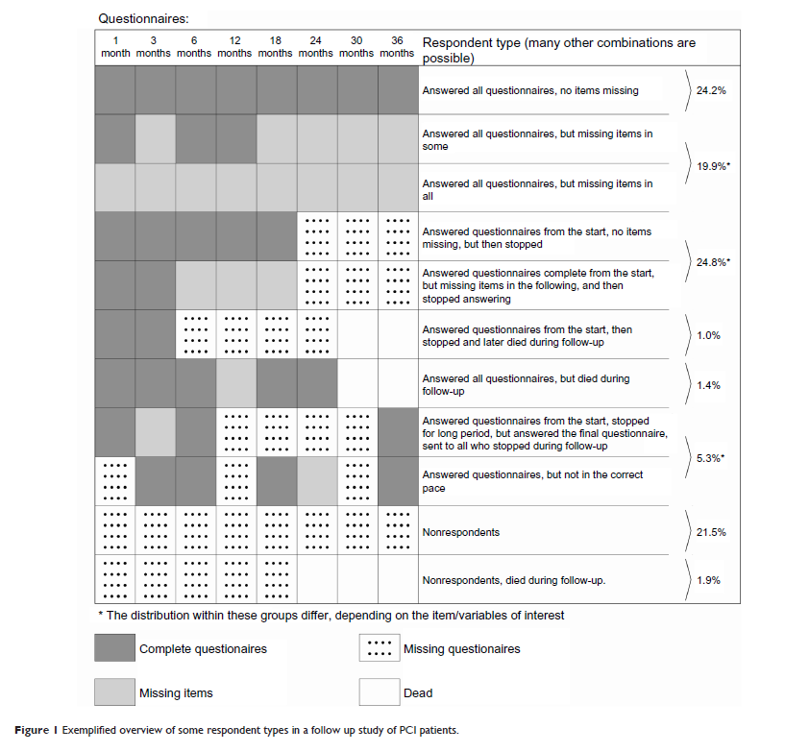
(From: Biering K, Hjollund NH, Frydenberg M. 2015. Using Multiple Imputation to Deal with Missing Data and Attrition in Longitudinal Studies with Repeated Measures of Patient-reported Outcomes. Clinical Epidemiology 7:91-106.)
Next, we turn to the long dataset to explore the amount of item non-response per person (we could also do it in a wide dataset).

. use "https://www.sarkisian.net/socy7706/hrs_hours_reshaped.dta", clear

In the long format, we first generate a count of missing values per line (which is one person-year):

. egen miss=rowmiss( rworkhours80 rpoorhealth rmarried rtotalpar rsiblog hchildlg rallparhelptw female age minority raedyrs)

. tab miss

miss | Freq. Percent Cum.
------------+-----------------------------------
0 | 30,541 55.86 55.86
1 | 15,034 27.50 83.35
2 | 1,436 2.63 85.98
3 | 143 0.26 86.24
4 | 7 0.01 86.26
5 | 3 0.01 86.26
6 | 7,506 13.73 99.99
7 | 6 0.01 100.00
------------+-----------------------------------
Total | 54,676 100.00

0 means no missing data at all in a given person-year; 7 means 7 out of 11 variables are missing data (probably all time-varying ones). Next, I generate an average number of missing values per year for each person (so an average of this count across time points for each person):

. bysort hhidpn: egen misstotal=mean(miss)

It makes sense to examine this per person since it's the average across years for each person. I'll mark one record per person (the first one) using the new variable I'll create, firstrecord. I could also create the same variable using tag function of egen, i.e. : egen taggedobs=tag(hhidpn)

. bysort hhidpn: gen firstrecord=1 if _n==1
(48,085 missing values generated)

Now I will tabulate misstotal with one observation per person:

. tab misstotal if firstrecord==1

misstotal | Freq. Percent Cum.
------------+-----------------------------------
0 | 1,228 18.63 18.63
.1111111 | 378 5.74 24.37
.125 | 15 0.23 24.59
.1428571 | 18 0.27 24.87
.1666667 | 11 0.17 25.03
.2 | 25 0.38 25.41
.2222222 | 354 5.37 30.78
.25 | 38 0.58 31.36
.2857143 | 12 0.18 31.54
.3333333 | 379 5.75 37.29
.375 | 17 0.26 37.55
.4 | 21 0.32 37.87
.4285714 | 14 0.21 38.08
.4444444 | 338 5.13 43.21
.5 | 102 1.55 44.76
.5555556 | 330 5.01 49.76
.5714286 | 16 0.24 50.01
.6 | 17 0.26 50.27
.625 | 22 0.33 50.60
.6666667 | 479 7.27 57.87
.7142857 | 13 0.20 58.06
.75 | 30 0.46 58.52
.7777778 | 410 6.22 64.74
.8 | 9 0.14 64.88
.8333333 | 6 0.09 64.97
.8571429 | 5 0.08 65.04
.875 | 8 0.12 65.16
.8888889 | 129 1.96 67.12
1 | 184 2.79 69.91
1.111111 | 86 1.30 71.22
1.125 | 5 0.08 71.29
1.142857 | 2 0.03 71.32
1.166667 | 4 0.06 71.39
1.2 | 2 0.03 71.42
1.222222 | 78 1.18 72.60
1.25 | 8 0.12 72.72
1.285714 | 1 0.02 72.74
1.333333 | 146 2.22 74.95
1.375 | 3 0.05 75.00
1.428571 | 2 0.03 75.03
1.444444 | 71 1.08 76.10
1.5 | 19 0.29 76.39
1.555556 | 69 1.05 77.44
1.571429 | 1 0.02 77.45
1.6 | 4 0.06 77.51
1.625 | 1 0.02 77.53
1.666667 | 74 1.12 78.65
1.714286 | 3 0.05 78.70
1.75 | 2 0.03 78.73
1.777778 | 46 0.70 79.43
1.833333 | 1 0.02 79.44
1.857143 | 1 0.02 79.46
1.888889 | 47 0.71 80.17
2 | 110 1.67 81.84
2.111111 | 45 0.68 82.52
2.166667 | 1 0.02 82.54
2.2 | 1 0.02 82.55
2.222222 | 40 0.61 83.16
2.333333 | 35 0.53 83.69
2.4 | 1 0.02 83.71
2.444444 | 32 0.49 84.19
2.5 | 2 0.03 84.22
2.555556 | 8 0.12 84.34
2.666667 | 116 1.76 86.10
2.777778 | 44 0.67 86.77
2.888889 | 39 0.59 87.36
3 | 48 0.73 88.09
3.111111 | 16 0.24 88.33
3.333333 | 128 1.94 90.27
3.444444 | 36 0.55 90.82
3.5 | 1 0.02 90.84
3.555556 | 29 0.44 91.28
3.666667 | 19 0.29 91.56
3.777778 | 5 0.08 91.64
3.888889 | 2 0.03 91.67
4 | 181 2.75 94.42
4.111111 | 40 0.61 95.02
4.222222 | 6 0.09 95.11
4.333333 | 11 0.17 95.28
4.444445 | 3 0.05 95.33
4.555555 | 2 0.03 95.36
4.666667 | 154 2.34 97.69
4.777778 | 9 0.14 97.83
4.888889 | 8 0.12 97.95
5 | 3 0.05 98.00
5.111111 | 2 0.03 98.03
5.222222 | 3 0.05 98.07
5.333333 | 117 1.78 99.85
5.444445 | 10 0.15 100.00
------------+-----------------------------------
Total | 6,591 100.00

Next, I will calculate how many waves of complete data each person has. I will use the missing data indicator I already created and generate a dichotomy based on that which marks the complete waves (1 if miss is 0, 0 otherwise):

. tab miss

miss | Freq. Percent Cum.
------------+-----------------------------------
0 | 30,541 55.86 55.86
1 | 15,034 27.50 83.35
2 | 1,436 2.63 85.98
3 | 143 0.26 86.24
4 | 7 0.01 86.26
5 | 3 0.01 86.26
6 | 7,506 13.73 99.99
7 | 6 0.01 100.00
------------+-----------------------------------
Total | 54,676 100.00

. gen nomiss=(miss==0)

. tab nomiss

nomiss | Freq. Percent Cum.
------------+-----------------------------------
0 | 24,135 44.14 44.14
1 | 30,541 55.86 100.00
------------+-----------------------------------
Total | 54,676 100.00

And now I will calculate a count of years of non-missing data per person:
. bysort hhidpn: egen nomisstotal=total(nomiss)

. tab nomisstotal if firstrecord==1

nomisstotal | Freq. Percent Cum.
------------+-----------------------------------
0 | 348 5.28 5.28
1 | 445 6.75 12.03
2 | 963 14.61 26.64
3 | 886 13.44 40.08
4 | 794 12.05 52.13
5 | 660 10.01 62.15
6 | 601 9.12 71.26
7 | 537 8.15 79.41
8 | 542 8.22 87.63
9 | 815 12.37 100.00
------------+-----------------------------------
Total | 6,591 100.00

So 815 people have all complete data for all 9 waves, 348 people have no complete waves, etc.

Methods of handling missing data

We will briefly address various naïve methods of dealing with missing data (that are no longer recommended), and learn to apply one of the more sophisticated techniques – multiple imputation by chained equations.

I. Available data approaches

1. Listwise (casewise) deletion
If an observation has missing data for any one variable used in a particular analysis, we can omit that observation from the analysis. This approach is the default method of handling incomplete data in Stata, as well as most other commonly-used statistical software.

There is no simple decision rule for whether to drop cases with missing values, or to impute values to replace missing values. Listwise deletion will produce unbiased results if the data are MCAR (but our sample will be smaller so the standard errors will be higher). When the data are MAR, listwise deletion produced biased results but they are actually less problematic than the results of many other common naïve methods of handling missing data. For instance, if the patterns of missing data on your independent variables are not related to the values of the dependent variables, listwise deletion will produce unbiased estimates.

Still, dropping cases with missing data can reduce our sample (and therefore also reduce the precision) substantially, and therefore we often want to avoid it. But when the number of cases with missing data is small (e.g., less than 5% in large samples), it is common simply to drop these cases from analysis.

2. Pairwise deletion
We can compute bivariate correlations or covariances for each pair of variables X and Y using all cases where neither X nor Y is missing – i.e., based upon the available pairwise data. To estimate means and variances of each of the variables, it uses all cases where that variable is not missing. We can then use these means and covariances in subsequent analyses.

Pairwise data deletion is available in a number of SAS and SPSS statistical procedures; Stata does not use it much and for a good reason – pairwise deletion produces biased results and shouldn’t be used.

3. Missing data indicators
In this method, we would create a dummy variable equal to 1 in cases where X is missing, and 0 in cases where it is not. Then we would include both X and the dummy variable in the model predicting Y. This is method is very problematic and results in biased estimates.

II. Deterministic imputation methods

1. Mean substitution
The simplest imputation method is to use a variable’s mean (or median) to fill in missing data values. This is only appropriate when the data are MCAR, and even then this method creates a spiked distribution at the mean in frequency distributions, lowers the correlations between the imputed variables and the other variables, and underestimates variance. Nevertheless, it is made available as an easy option in many SPSS procedures, and there is a procedure (STANDARD) available for that in SAS. Still, you should avoid using it.

A type of mean substitution where the mean is calculated in a subgroup of the non-missing values, rather than all of them, is also sometimes used; this technique also suffers from the same problems.

2. Single regression imputation (a.k.a. conditional mean substitution)
A better method than to impute using each variable’s mean is to use regression analysis on cases without missing data, and then use those regression equations to predict values for the cases with missing data. This imputation technique is available in many statistical packages (for example, in Stata there is “impute” command). This technique still has the problem that all cases with the same values on the independent variables will be imputed with the same value on the missing variable, thus leading to an underestimate of variance; thus, the standard errors in your models will be lower than they should be.

3. Single random (stochastic) regression imputation
To improve upon the single regression imputation method, and especially to compensate for its tendency to lower the variance and therefore lead to an underestimation of standard errors, we can add uncertainty to the imputation of each variable so each imputed case would get a different value. This is done by adding a random value to the predicted result. This random value is usually the regression residual from a randomly selected case from the set of cases with no missing values. SPSS offers stochastic regression imputation – when doing regression imputation, SPSS by default adds the residual of a randomly picked case to each estimate. Impute command in Stata does not offer such an option, but one can use ice command we will learn soon to generate such imputations.

Single random regression imputation is better than regular regression imputation because it preserves the properties of the data both in terms of means and in terms of variation. Still, this residual is just a guess and it is likely that standard errors will be smaller than they should be. Another remaining problem, but it’s a serious one, is that it uses imputed data as if they were real – it doesn't allow for the variation between different possible sets of imputed values. That’s why we need to move beyond the traditional approaches to those that try to recognize the difference between real and imputed data.

4. Hot deck imputation
As opposed to regression imputation, hotdeck imputation is a nonparametric imputation technique (i.e., doesn’t depend on estimating regression parameters). Hot deck imputation involves identifying the most similar case to the case with a missing value and substituting that most similar case’s value for the missing value. We need to specify which variables are used to define such similarity – these variables should be related to the variable that’s being imputed. Thus, a number of categorical variables are used to form groups, and then cases are randomly picked within those groups. For example:

Obs | Var 1 | Var 2 | Var 3 | Var 4
1 | 4 | 1 | 2 | 3
2 | 5 | 4 | 2 | 5
3 | 3 | 4 | 2 | .

Hot deck imputation examines the observations with complete records (obs 1 and 2) and substitutes the value of the most similar observation for the missing data point. Here, obs 2 is more similar to obs 3 than obs 1. New data matrix:

Obs | Var 1 | Var 2 | Var 3 | Var 4
1 | 4 | 1 | 2 | 3
2 | 5 | 4 | 2 | 5
3 | 3 | 4 | 2 | 5
After doing this imputation, we analyze the data using the complete database. Stata offers a hot deck algorithm implemented in the hotdeck command. This procedure will tabulate the missing data patterns for the selected variables and will define a row of data with missing values in any of the variables as a `missing line' of data, similarly a `complete line' is one where all the variables contain data. The hotdeck procedure replaces the variables in the `missing lines' with the corresponding values in the `complete lines'. It does so within the groups specified by the “by” variables. Note that if a dataset contains many variables with missing values then it is possible that many of the rows of data will contain at least one missing value. The hotdeck procedure will not work very well in such circumstances. Also, hotdeck procedure assumes is that the missing data are MAR and that the probability of missing data can be fully accounted for by the categorical variables specified in the `by' option.

Hotdeck imputation allows imputing with real, existing values (so categorical variables remain categorical and continuous variables remain continuous). But it can be difficult to define "similarity." Also, once again this approach does not distinguish between real and imputed data and therefore will result in standard errors that are too low.

II. Maximum likelihood methods

The second group of methods we will consider are those based on maximum likelihood estimation. There are two types of techniques in this group.

1. Expectation Maximization (EM) approach:
EM approach is a technique uses ML algorithm to generate a covariance matrix and mean estimates given the available data, and then these estimates can be used in further analyses. All the estimates are obtained through an iterative procedure, and each iteration has two steps. First, in the expectation (E) step, we take estimates of the variances, covariances and means, perhaps from listwise deletion, use these estimates to obtain regression coefficients, and then fill in the missing data based on those coefficients. In the maximization (M) step, having filled in missing data, we use the complete data (using estimated values) to recalculate variances, covariances, and means. These are substituted back into the E step. The procedure iterates through these two steps until convergence is obtained (convergence occurs when the change of the parameter estimates from iteration to iteration becomes negligible). At that point we have maximum likelihood estimates of variances, covariances, and means, and we can use those to make the maximum likelihood estimates of the regression coefficients. Note that the actual imputed data are not generated in this process; only the parameter estimates.

The SPSS Missing Values Analysis (MVA) module uses the EM approach to missing data handling, and it’s also available in SAS as SAS-MI; as far as I know, it is not available in Stata.

The strength of the approach is that it has well-known statistical properties and it generally outperforms available data methods and deterministic methods. The main disadvantage is that it adds no uncertainty component to the estimated data. Thus, it still underestimates the standard errors of the coefficients.

2. Direct ML methods
There are alternative maximum likelihood estimators that are better than the ones obtained by the EM algorithm; these involve direct ML method, also known as raw maximum likelihood method, or Full Information Maximum Likelihood estimation (FIML). This technique uses all available data to generate maximum likelihood-based statistics. Like EM algorithm, direct ML methods assume the missing values are MAR. Under an unrestricted mean and covariance structure, direct ML and EM return identical parameter estimate values. Unlike EM, however, direct ML can be employed in the context of fitting user-specified linear models. Direct ML methods are model-based, that is, implemented as part of a fitted statistical model. This produces standard errors and parameter estimates under the assumption that the fitted model is not false, so parameter estimates and standard errors are model-dependent. But it also makes it difficult to use variables that are not in the model in your imputation.

Direct ML has the advantage of convenience/ease of use and well-known statistical properties. Unlike EM, it also allows for the direct computation of appropriate standard errors and test statistics. Disadvantages include an assumption of joint multivariate normality of the variables used in the analysis and the lack of an imputed dataset produced by the analysis.

Direct ML method is implemented by the EM algorithm in the SPSS Missing Values option and MIXED procedure in SAS. It is also available in structural equation modeling packages, such as AMOS, LISREL, MPlus, as well as Stata SEM module.

III. Multiple imputation

An alternative to the maximum likelihood is called multiple imputation (MI). In multiple imputation we generate imputed values on the basis of existing data, but we do the imputation more than once, each time including a random component in our imputation. This allows us to prevent underestimating the standard errors of our regression coefficients. We do that by combining coefficient estimates from multiple datasets using special formulas for the standard errors. Specifically, the standard error of such estimates is equal to SQRT[(1 - 1/m)/B +W], where m is the number of replicates, B is the variance of the imputations, and W is the average of the estimated variance.

Multiple imputation is a sort of an approximation to Direct ML. In multiple imputation, we try a few plausible values of missing data. In maximum likelihood, we integrate over all possible data values, giving more weight to values that are more plausible. MI has the advantage of simplicity over Maximum Likelihood methods, making it particularly suitable for large datasets. The efficiency of MI is high even when the number of imputed datasets is low (3-10), although recent literature suggests that this depends on the amount of missing data--larger amount may necessitate more imputed datasets.

1. Multiple hot deck imputation
Multiple hot deck imputation combines the well-known statistical advantages of EM and direct ML with the ability of hot deck imputation to provide a raw data matrix. The primary difference between multiple hot deck imputation and regular hot deck imputation is that multiple imputation requires that we generate five to ten datasets with imputed values. We then analyze each database and summarize the results into one summary set of findings. Stata offers multiple hot deck imputation as a part of the same hotdeck command we discussed earlier.

2. Multiple Imputation under the Multivariate Normal Model

In this approach, multiple datasets are generated with methods somewhat similar to single random regression imputation, but with some important modifications. To impute the missing values, we use the information from available data to generate a distribution of plausible values for the missing data, and draw from that distribution at random multiple times to produce multiple datasets. The imputed value is affected by two sources of random variation:
(1) It is a random draw from a conditional distribution.
(2) The conditional distribution itself must be estimated, and the estimation contains some error.

Under this method, the model for the missing data given the observed is a fully specified joint model (e.g. multivariate normal). This is difficult to specify for a mixture of continuous and categorical data. Therefore this method assumes all data are normal. But luckily, tests suggest that this type of imputation is quite robust even when the simulation is based on an erroneous model (e.g., when normality is assumed even though the underlying data are not in fact normal).
In Stata, it is available as a part of the MI package: see mi impute mvn. Since this method assumes that all variables are continuous (even though it is fairly robust to that violation), we will focus on learning another method, also implemented in Stata, that does not make that assumption.

3. Multiple Imputation by Chained Equations (MICE)
Chained equations method has a similar idea but adopts a different approach. No joint distribution is set up. Rather, we use a series of conditional distributions. E.g. if we have a continuous X, a count variable Y, and a binary Z, and some data for each are missing, we set up (1) a linear regression of X on Y and Z, (2) a Poisson regression of Y on X and Z, and (3) a logistic regression of Z on X and Y. We start by fitting (1) to the observed data, then simulate any missing X from that model. Then we fit (2) using observed Z and X (with missing values filled out by the simulations), and simulate any missing Y. Then we fit (3) using X and Y (with missing values filled by the simulations). We go through multiple iterations, fitting each model in turn, and updating the simulations with each iteration, waiting for the model to converge. We do that multiple times producing multiple datasets.

MICE is computationally simple to implement, and is available in Stata. The drawback is that the conditionals may not specify a unique joint distribution which can make the inferences problematic; but the simulation studies suggest it often works quite well, so it is increasingly used.

A few rules crucial for implementing any type of MI:
- All variables included in your models should be included in the imputation process; you can also add auxiliary variables that would improve predictions for some variables included in the model.
- Dependent variable should always be included in the imputation process, but there are different opinions on whether their imputed values should be subsequently discarded (this is called MID—multiple imputation then deletion) – for a while, the consensus was that MID was better than regular MI (i.e., that it is better to drop the imputed values of the dependent variable), but recent work suggests that the two approaches produce equivalent results. What is clear is that it is definitely beneficial to keep imputed values of the dependent variable in a situation when additional variables were used in imputing this dependent variable—such supplementary variables enhance the imputation of the dependent variable but are not included in final data analysis models. In this case, imputed values of the dependent variable contain extra information and should definitely be preserved. (To better understand this situation, see: von Hippel, Paul T. 2007. Regression with Missing Ys: An Improved Strategy for Analyzing Multiply Imputed Data. Sociological Methodology 37(1), 83-117.)
- If you have interactions or nonlinear relationships among the variables, you should create the variables for those before doing the imputations – otherwise the imputed values will only reflect the linear relationships among the variables. There is some disagreement, however, whether those interactions and nonlinear terms should be imputed separately (this is known as “Just Another Variable” approach) or be a product of imputations of main terms.
- If you are using categorical variables as sets of dummies, you need to create single variables representing those sets before doing the imputation, even if you only plan to use them as dummies later on.
- It is helpful to transform skewed variables before imputing, then back-transform them for analyses.
- Only “soft” missing data (those denoted by just a dot) get imputed – “hard” missing data – e.g., .a, .b, etc. – do not get imputed. Only “soft” missing data (those denoted by just a dot) get imputed – “hard” missing data – e.g., .a, .b, etc. – do not get imputed. In some versions of the command (mi impute chained rather than ice), hard missing data will present problems when imputing other values and you need to decide how to handle them – either exclude these observations from imputation, or allow for them to be soft missing and imputed and then delete, or exclude this variable from the imputation of the others, or replace with a value of 0 and include a separate dummy indicating the not applicable group (e.g., put 0 for marital satisfaction for the unmarried and include a married/unmarried dichotomy).
- Another issue to consider when using multiple imputation is the number of datasets to impute. The larger the amount of missing data, the more datasets you’d need to avoid loss of efficiency. The most common choice these days seems to be 20. You can consult the following article for the info on the number of imputations: Graham, J. W., A. E. Olchowski, and T. D. Gilreath. 2007. How many imputations are really needed? Some practical clarifications of multiple imputation theory. Prevention Science 8(3): 206-213.
- If you want to do exploratory analyses, generate an extra imputed dataset specifically for that part of the analysis; then, for the final results, run your model on a number of other imputed datasets, not including the preliminary one.
- Multiple imputation of a longitudinal dataset should be done on a wide rather than long dataset (i.e., there should be separate variables for each year of data, rather than multiple observations within each case). That will allow you to use observations from one year to impute data in another year, which will improve the quality of prediction as well as account for the clustered nature of the data. To change between long and wide format of data in Stata, you can use reshape command (or mi reshape after imputation).
- For a longitudinal dataset, additional problems will be created by attrition—loss of cases over time for various reasons. It is possible to estimate models even if you have different number of time points for different cases, but oftentimes it is useful to conduct sensitivity analyses and check how the results would look like if those cases that are missing entirely at certain time points are imputed (either under MAR assumption or using, for example, sensitivity testing approaches for NMAR; see below).
- If you plan to use mixed effects models with random slopes, you should try to include interactions of level 2 ID dummies with each of the independent variables that should have random slopes, although this will likely be too many variables, especially if you have multiple random slopes. (You might want to explore the issue of which random slopes you want to include using listwise deletion dataset in order to limit the number of interactions to include.) Alternatively, you may want to use a specialized R package for multilevel data.

Learning to use MICE

MICE is available both within the mi module in Stata as well as a separate package. I will mostly demonstrate its use with the separate package but also introduce the mi module version (mi impute chained).

For a separate module, you find the command using
. net search mice

You need to install st0067_4 from http://www.stata-journal.com/software/sj9-3

Here’s the syntax:
ice mainvarlist [if] [in] [weight] [, ice_major_options ice_less_used_options]

ice_major_options description
------------------------------------------------------------------------
clear clears the original data from memory and
loads the imputed dataset into memory
dryrun reports the prediction equations -- no
imputations are done
eq(eqlist) defines customized prediction equations
m(#) defines the number of imputations
match[(varlist)] prediction matching for each member of
varlist
passive(passivelist) passive imputation
saving(filename [, replace]) imputed and nonimputed variables are
stored to filename
------------------------------------------------------------------------

ice_less_used_options description
------------------------------------------------------------------------
boot[(varlist)] estimates regression coefficients for
varlist in a bootstrap sample
by(varlist) imputation within the levels implied by
varlist
cc(varlist) prevents imputation of missing data in
observations in which varlist has a
missing value
cmd(cmdlist) defines regression command(s) to be used
for imputation
conditional(condlist) conditional imputation
cycles(#) determines number of cycles of regression
switching
dropmissing omits all observations not in the
estimation sample from the output
eqdrop(eqdroplist) removes variables from prediction
equations
genmiss(string) creates missingness indicator variable(s)
id(newvar) creates newvar containing the original
sort order of the data
interval(intlist) imputes interval-censored variables
monotone assumes pattern of missingness is
monotone, and creates relevant
prediction equations
noconstant suppresses the regression constant
nopp suppresses special treatment of perfect
prediction
noshoweq suppresses presentation of prediction
equations
noverbose suppresses messages showing the progress
of the imputations
nowarning suppresses warning messages
on(varlist) imputes each member of mainvarlist
univariately
orderasis enters the variables in the order given
persist ignores errors when trying to impute
"difficult" variables and/or models
restrict([varname] [if]) fits models on a specified subsample,
impute missing data for entire
estimation sample
seed(#) sets random-number seed
substitute(sublist) substitutes dummy variables for multilevel
categorical variables
trace(trace_filename) monitors convergence of the imputation
algorithm
------------------------------------------------------------------------
Sets of imputed and nonimputed variables are stored to a new file specified using saving option. Option replace permits filename to be overwritten with new data. Any number of complete imputations may be created (defined by option m). Let’s see an example, and then we’ll examine a few options. We will use a small, NLSY-based dataset on marriage and employment. Since this dataset is longitudinal, as mentioned above, we should impute it in wide format.

. use https://www.sarkisian.net/socy7706/marriage.dta

. reshape wide interv mar educ emp enrol, i(id) j(year)
(note: j = 83 84 85 86 87 88 89 90 91 92 93 94)

Data long -> wide
-----------------------------------------------------------------------------
Number of obs. 72972 -> 6081
Number of variables 11 -> 65
j variable (12 values) year -> (dropped)
xij variables:
interv -> interv83 interv84 ... interv94
mar -> mar83 mar84 ... mar94
educ -> educ83 educ84 ... educ94
emp -> emp83 emp84 ... emp94
enrol -> enrol83 enrol84 ... enrol94
-----------------------------------------------------------------------------

Before we run actual multiple imputation using ICE, we will do a dry run – check that everything looks correct, without generating actual datasets:

. ice mar* educ* emp* enrol* birthdate m.race parpres pared, saving(marriage_imputed.dta, replace) m(5) dryrun

=> xi: ice mar83 mar84 mar85 mar86 mar87 mar88 mar89 mar90 mar91 mar92 mar93 mar94 educ83 educ84 educ8
> 5 educ86 educ87 educ88 educ89 educ90 educ91 educ92 educ93 educ94 emp83 emp84 emp85 emp86 emp87 emp88
> emp89 emp90 emp91 emp92 emp93 emp94 enrol83 enrol84 enrol85 enrol86 enrol87 enrol88 enrol89 enrol90
> enrol91 enrol92 enrol93 enrol94 birthdate race i.race parpres pared, cmd(race:mlogit) substitute(ra
> ce:i.race) saving(L:\socy7706\marriage_imputed.dta, replace) m(5) dryrun

i.race _Irace_1-3 (naturally coded; _Irace_1 omitted)

#missing |
values | Freq. Percent Cum.
------------+-----------------------------------
0 | 43 0.71 0.71
1 | 228 3.75 4.46
2 | 494 8.12 12.58
3 | 821 13.50 26.08
4 | 1,029 16.92 43.00
5 | 1,015 16.69 59.69
6 | 833 13.70 73.39
7 | 617 10.15 83.54
8 | 459 7.55 91.09
9 | 254 4.18 95.26
10 | 137 2.25 97.52
11 | 77 1.27 98.78
12 | 31 0.51 99.29
13 | 29 0.48 99.77
14 | 12 0.20 99.97
15 | 2 0.03 100.00
------------+-----------------------------------
Total | 6,081 100.00

Variable | Command | Prediction equation
------------+---------+-------------------------------------------------------
mar83 | logit | mar84 mar85 mar86 mar87 mar88 mar89 mar90 mar91 mar92
| | mar93 mar94 educ83 educ84 educ85 educ86 educ87 educ88
| | educ89 educ90 educ91 educ92 educ93 educ94 emp83 emp84
| | emp85 emp86 emp87 emp88 emp89 emp90 emp91 emp92 emp93
| | emp94 enrol83 enrol84 enrol85 enrol86 enrol87 enrol88
| | enrol89 enrol90 enrol91 enrol92 enrol93 enrol94
| | birthdate _Irace_2 _Irace_3 parpres pared
[output omitted]

_Irace_2 | | [Passively imputed from (race==2)]
_Irace_3 | | [Passively imputed from (race==3)]
parpres | regress | mar83 mar84 mar85 mar86 mar87 mar88 mar89 mar90 mar91
| | mar92 mar93 mar94 educ83 educ84 educ85 educ86 educ87
| | educ88 educ89 educ90 educ91 educ92 educ93 educ94 emp83
| | emp84 emp85 emp86 emp87 emp88 emp89 emp90 emp91 emp92
| | emp93 emp94 enrol83 enrol84 enrol85 enrol86 enrol87
| | enrol88 enrol89 enrol90 enrol91 enrol92 enrol93
| | enrol94 birthdate _Irace_2 _Irace_3 pared
pared | regress | mar83 mar84 mar85 mar86 mar87 mar88 mar89 mar90 mar91
| | mar92 mar93 mar94 educ83 educ84 educ85 educ86 educ87
| | educ88 educ89 educ90 educ91 educ92 educ93 educ94 emp83
| | emp84 emp85 emp86 emp87 emp88 emp89 emp90 emp91 emp92
| | emp93 emp94 enrol83 enrol84 enrol85 enrol86 enrol87
| | enrol88 enrol89 enrol90 enrol91 enrol92 enrol93
| | enrol94 birthdate _Irace_2 _Irace_3 parpres
------------------------------------------------------------------------------

End of dry run. No imputations were done, no files were created.

Note that we specified race as m.race – that tells Stata that we want to use mlogit to impute race and that we want to use race as a set of dummies when imputing other variables. If we want to use ologit instead to impute a variable, we would use o. instead of m. prefix. This is the best way to use multicategory variables in imputation. If you have a number of dummies instead (e.g., if we had separate dummies for black and Hispanic), it is a good idea to generate a multicategory variable first and use that variable rather than separate dummies in the imputation process—otherwise, your dummies will be imputed independently and therefore can end up overlapping.
Some options for ice (see help ice for more):

cmd option: This option allows us to specify what command we want to use to impute a given variable. The default cmd for a variable is logit when there are two distinct values, mlogit when there are 3-5 and regress otherwise. Note that unless the dataset is large, use of the mlogit command may produce unstable estimates if the number of levels is too large.

For example, if we want educ to be used in other imputations as continuous but to be imputed using ordered logit, we can specify:

. ice mar* educ* emp* enrol* birthdate m.race parpres pared, saving(L:\socy7706\marriage_imputed.dta, replace) m(5) dryrun cmd(educ*: ologit)

eq(eqlist) option: This option allows one to define customized prediction equations for any subset of variables. The default is that each variable in mainvarlist with any missing data is imputed from all the other variables in mainvarlist. The option allows great flexibility in the possible imputation schemes. The syntax of eqlist is varname1:varlist1 [,varname2:varlist2 ...], where each varname# (or varlist#) is a member (or subset) of mainvarlist. It is important to ensure that each equation is sensible. ice places no restrictions except to check that all variables mentioned are indeed in mainvarlist. For example, we could specify:

ice mar* educ* emp* enrol* birthdate m.race parpres pared, saving(L:\socy7706\marriage_imputed.dta, replace) eq(mar*: emp* educ* birthdate _Irace_2 _Irace_3) m(5) dryrun

genmiss(name) option: This option creates an indicator variable for the missingness of data in any variable in mainvarlist for which at least one value has been imputed. The indicator variable is set to missing for observations excluded by if, in, etc. The indicator variable for xvar is named namexvar (of course, you get to specify the actual name).

Passive option: If we are using interactions, for example, between x1 and x2 (e.g., x12=x1*x2), we can use passive option, passive(x12:x1*x2). For example:

. ice mar* educ* emp* enrol* birthdate m.race parpres pared paprespared, saving(L:\socy7706\marriage_imputed.dta, replace) m(5) dryrun passive(parprespared: parpres*pared)

However, some people recently have been arguing that interactions and nonlinear terms should not be imputed passively and instead should be imputed separately – this is known as “Just Another Variable” approach.

Persist option: If we are using a lot of dummies, we are likely to run into errors when running imputation, especially in logit-based models. You can tell Stata to ignore those errors by specifying “persist” option; however, the resulting imputation would be problematic. You might want to use it to see which variables keep creating errors and then exclude those variables from corresponding equations using eqdrop option.

Eqdrop option: This option specifies which variables to omit from certain equations. You should omit as little as possible in order to make imputation run. The syntax of eqdroplist is varname1:varlist1 [, varname2:varlist2 ...]. For example:

. ice mar* educ* emp* enrol* birthdate m.race parpres pared, saving(L:\socy7706\marriage_imputed.dta, replace) eqdrop(emp*: birthdate _Irace_2 _Irace_3, mar*: pared parpres) m(5) dryrun

Conditional option: This option specifies criteria for inclusion/exclusion of cases during imputation; it is useful when your variable should only have values for a subset for the whole sample. For example:

. ice mar* marsat* educ* emp* emphrs* enrol* birthdate m.race parpres pared, saving(marriage_imputed.dta, replace) m(5) dryrun conditional(emphrs: emp=1 \ marsat: mar==1)

Interval option: This option can be used to limit the range of a variable during imputation (because it should not be top or bottom coded afterwards!):

gen paredll=pared
gen paredul=pared
replace paredll=0 if pared==.
replace paredul=20 if pared==.
ice mar* educ* emp* enrol* birthdate m.race parpres pared paredll paredul, saving(L:\socy7706\marriage_imputed.dta, replace) m(5) interval(pared: paredll paredul)

Seed option: This option allows to make a fixed starting point for random number generation, so that every time you run that command, you get exactly the same imputed datasets rather than different ones every time. For example:

ice mar* marsat* educ* emp* emphrs* enrol* birthdate m.race parpres pared, saving(marriage_imputed.dta, replace) m(5) dryrun seed(1234)

If your dataset is large and your model includes many variables, you might run into problems running imputation in Intercooled Stata (Stata IC). In that case, try Stata SE (that’s what we are using on Citrix anyways). Note that imputation is often a pretty slow process, especially if your dataset is large. And you often have to keep adjusting the imputation model until it runs without errors.

Since our dry run looked good, we can generate imputed data:

. ice mar* educ* emp* enrol* birthdate m.race parpres pared, saving(L:\socy7706\marriage_imputed.dta, replace) m(5) genmiss(mv_)
[Output omitted]
Imputing
[Perfect prediction detected: using auglogit to impute enrol84]
..........1
[Perfect prediction detected: using auglogit to impute enrol84]
..........2
[Perfect prediction detected: using auglogit to impute enrol84]
..........3
[Perfect prediction detected: using auglogit to impute enrol84]
..........4
[Perfect prediction detected: using auglogit to impute enrol84]
..........5
(note: file L:\socy7706\marriage_imputed.dta not found)
file L:\socy7706\marriage_imputed.dta saved

Stata built-in module

To do the same thing with the Stata built-in module:
. mi set wide
. mi register imputed mar* educ* emp* enrol* race parpres pared
. mi register regular birthdate

. mi impute chained (logit) mar* emp* enrol* (mlogit) race (reg) educ* parpres pared = birthdate, add(5) augment
variable ident not found
Your mi data are xtset and some of the variables previously declared by xtset are not in the
dataset. mi verifies that none of the xtset variables are also registered as imputed or
passive. Type mi xtset, clear to clear old no-longer-valid settings.
r(111);

. mi xtset, clear

. mi impute chained (logit) mar* emp* enrol* (mlogit) race (reg) educ* parpres pared = birthdate, add(5) augment

Conditional models:
race: mlogit race pared parpres i.enrol92 i.enrol94 i.enrol84 i.enrol89 i.enrol91 i.enrol90 i.enrol93 i.enrol83 i.enrol85 i.enrol87 i.enrol88 i.enrol86 i.emp83 i.emp85 i.emp84 educ83 educ90 educ92 i.emp93 i.emp87 educ84 educ93 educ85 educ91 educ94 educ87 i.emp86 i.emp88 i.emp91 i.emp89 educ89 i.emp92 i.emp94 educ88 educ86 i.emp90 i.mar93 i.mar90 i.mar94 i.mar91 i.mar92 i.mar84 i.mar87 i.mar85 i.mar89 i.mar86 i.mar83 i.mar88 birthdate , augment
pared: regress pared i.race parpres i.enrol92 i.enrol94 i.enrol84 i.enrol89 i.enrol91 i.enrol90 i.enrol93 i.enrol83 i.enrol85 i.enrol87 i.enrol88 i.enrol86 i.emp83 i.emp85 i.emp84 educ83 educ90 educ92 i.emp93 i.emp87 educ84 educ93 educ85 educ91 educ94 educ87 i.emp86 i.emp88 i.emp91 i.emp89 educ89 i.emp92 i.emp94 educ88 educ86 i.emp90 i.mar93 i.mar90 i.mar94 i.mar91 i.mar92 i.mar84 i.mar87 i.mar85 i.mar89 i.mar86 i.mar83 i.mar88 birthdate
parpres: regress parpres i.race pared i.enrol92 i.enrol94 i.enrol84 i.enrol89 i.enrol91 i.enrol90 i.enrol93 i.enrol83 i.enrol85 i.enrol87 i.enrol88 i.enrol86 i.emp83 i.emp85 i.emp84 educ83 educ90 educ92 i.emp93 i.emp87 educ84 educ93 educ85 educ91 educ94 educ87 i.emp86 i.emp88 i.emp91 i.emp89 educ89 i.emp92 i.emp94 educ88 educ86 i.emp90 i.mar93 i.mar90 i.mar94 i.mar91 i.mar92 i.mar84 i.mar87 i.mar85 i.mar89 i.mar86 i.mar83 i.mar88 birthdate
enrol92: logit enrol92 i.race pared parpres i.enrol94 i.enrol84 i.enrol89 i.enrol91 i.enrol90 i.enrol93 i.enrol83 i.enrol85 i.enrol87 i.enrol88 i.enrol86 i.emp83 i.emp85 i.emp84 educ83 educ90 educ92 i.emp93 i.emp87 educ84 educ93 educ85 educ91 educ94 educ87 i.emp86 i.emp88 i.emp91 i.emp89 educ89 i.emp92 i.emp94 educ88 educ86 i.emp90 i.mar93 i.mar90 i.mar94 i.mar91 i.mar92 i.mar84 i.mar87 i.mar85 i.mar89 i.mar86 i.mar83 i.mar88 birthdate , augment

[output omitted]

Performing chained iterations ...

Multivariate imputation Imputations = 5
Chained equations added = 5
Imputed: m=1 through m=5 updated = 0

Initialization: monotone Iterations = 50
burn-in = 10

mar83: logistic regression
mar84: logistic regression
mar85: logistic regression
mar86: logistic regression
mar87: logistic regression
mar88: logistic regression
mar89: logistic regression
mar90: logistic regression
mar91: logistic regression
mar92: logistic regression
mar93: logistic regression
mar94: logistic regression
emp83: logistic regression
emp84: logistic regression
emp85: logistic regression
emp86: logistic regression
emp87: logistic regression
emp88: logistic regression
emp89: logistic regression
emp90: logistic regression
emp91: logistic regression
emp92: logistic regression
emp93: logistic regression
emp94: logistic regression
enrol83: augmented logistic regression
enrol84: augmented logistic regression
enrol85: logistic regression
enrol86: logistic regression
enrol87: logistic regression
enrol88: logistic regression
enrol89: logistic regression
enrol90: logistic regression
enrol91: logistic regression
enrol92: logistic regression
enrol93: logistic regression
enrol94: logistic regression
race: multinomial logistic regression
educ83: linear regression
educ84: linear regression
educ85: linear regression
educ86: linear regression
educ87: linear regression
educ88: linear regression
educ89: linear regression
educ90: linear regression
educ91: linear regression
educ92: linear regression
educ93: linear regression
educ94: linear regression
parpres: linear regression
pared: linear regression

------------------------------------------------------------------
| Observations per m
|----------------------------------------------
Variable | Complete Incomplete Imputed | Total
-------------------+-----------------------------------+----------
mar83 | 5004 1077 1077 | 6081
mar84 | 5041 1040 1040 | 6081
mar85 | 5032 1049 1049 | 6081
mar86 | 5016 1065 1065 | 6081
mar87 | 5037 1044 1044 | 6081
mar88 | 5003 1078 1078 | 6081
mar89 | 5023 1058 1058 | 6081
mar90 | 5124 957 957 | 6081
mar91 | 5091 990 990 | 6081
mar92 | 5088 993 993 | 6081
mar93 | 5131 950 950 | 6081
mar94 | 5105 976 976 | 6081
emp83 | 5508 573 573 | 6081
emp84 | 5471 610 610 | 6081
emp85 | 5487 594 594 | 6081
emp86 | 5416 665 665 | 6081
emp87 | 5443 638 638 | 6081
emp88 | 5413 668 668 | 6081
emp89 | 5410 671 671 | 6081
emp90 | 5390 691 691 | 6081
emp91 | 5412 669 669 | 6081
emp92 | 5409 672 672 | 6081
emp93 | 5446 635 635 | 6081
emp94 | 5406 675 675 | 6081
enrol83 | 5823 258 258 | 6081
enrol84 | 5843 238 238 | 6081
enrol85 | 5819 262 262 | 6081
enrol86 | 5808 273 273 | 6081
enrol87 | 5819 262 262 | 6081
enrol88 | 5813 268 268 | 6081
enrol89 | 5840 241 241 | 6081
enrol90 | 5835 246 246 | 6081
enrol91 | 5839 242 242 | 6081
enrol92 | 5857 224 224 | 6081
enrol93 | 5825 256 256 | 6081
enrol94 | 5855 226 226 | 6081
race | 6019 62 62 | 6081
educ83 | 5466 615 615 | 6081
educ84 | 5440 641 641 | 6081
educ85 | 5434 647 647 | 6081
educ86 | 5395 686 686 | 6081
educ87 | 5419 662 662 | 6081
educ88 | 5399 682 682 | 6081
educ89 | 5410 671 671 | 6081
educ90 | 5455 626 626 | 6081
educ91 | 5423 658 658 | 6081
educ92 | 5450 631 631 | 6081
educ93 | 5435 646 646 | 6081
educ94 | 5422 659 659 | 6081
parpres | 5868 213 213 | 6081
pared | 5905 176 176 | 6081
------------------------------------------------------------------
(complete + incomplete = total; imputed is the minimum across m
of the number of filled-in observations.)

Warning: the sets of predictors of the imputation model vary across
imputations or iterations

Note that if any of your variables that are used but not imputed (variables after =) should be sets of dummies, use i. before these variables’ names in the command.

Some helpful options of mi impute include:

dryrun – same as for ice; specify equations but not run the actual imputation
rseed(#) – specify random-number seed in order to create imputations in a replicable fashion
by(varlist) – impute separately on each group formed by varlist
include – specify what to incude in the imputation equation
omit – to omit certain variables from some equations, e.g:

mi impute chained (logit) mar* emp* enrol* (mlogit, omit(birthdate)) race (reg) educ* parpres pared = birthdate, add(5) augment

Estimation after multiple imputation
To obtain final estimates of the parameters of interest and their standard errors, one would fit a model in each imputation and carry out the appropriate post-MI averaging procedure on the results. In Stata, you can do that using mi estimate. It supports a wide range of commands:

The following estimation commands support the mi estimate prefix.

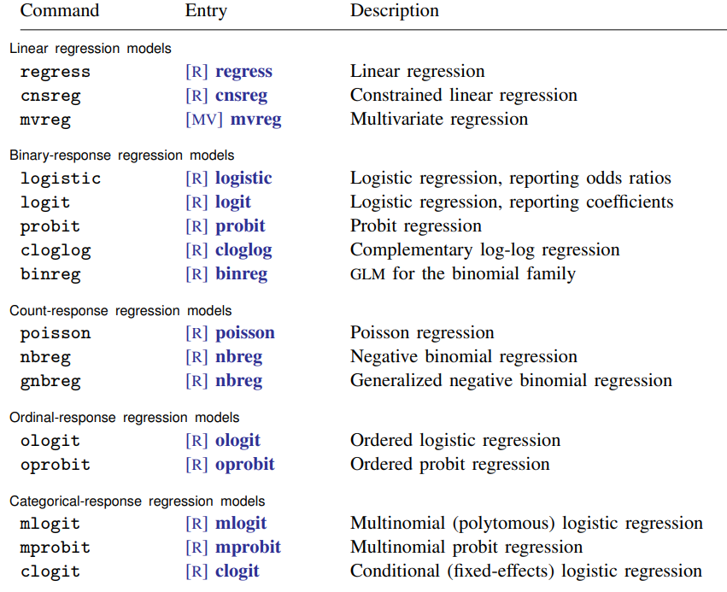
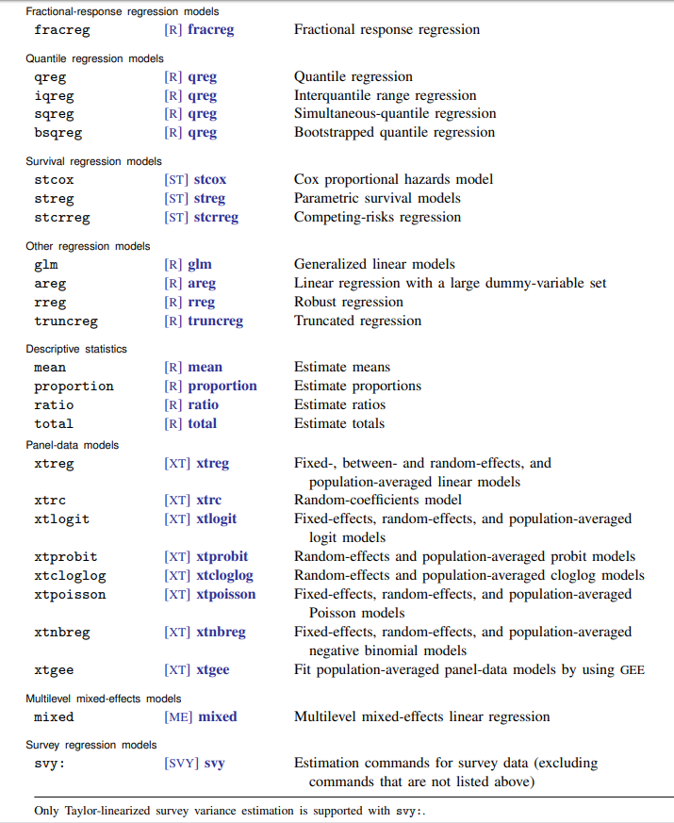

First, if we generated our imputed data using the separate ICE module, we have to do mi import to convert the data from MICE format into the format used by MI commands:

. use "L:\socy7706\marriage_imputed.dta", clear

. tab _mj

imputation |
number | Freq. Percent Cum.
------------+-----------------------------------
0 | 6,081 16.67 16.67
1 | 6,081 16.67 33.33
2 | 6,081 16.67 50.00
3 | 6,081 16.67 66.67
4 | 6,081 16.67 83.33
5 | 6,081 16.67 100.00
------------+-----------------------------------
Total | 36,486 100.00

. mi import ice

. tab _mi_m

_mi_m | Freq. Percent Cum.
------------+-----------------------------------
0 | 6,081 16.67 16.67
1 | 6,081 16.67 33.33
2 | 6,081 16.67 50.00
3 | 6,081 16.67 66.67
4 | 6,081 16.67 83.33
5 | 6,081 16.67 100.00
------------+-----------------------------------
Total | 36,486 100.00

. tab _mi_miss

_mi_miss | Freq. Percent Cum.
------------+-----------------------------------
0 | 6,081 100.00 100.00
------------+-----------------------------------
Total | 6,081 100.00

. sum _mi_id

Variable | Obs Mean Std. Dev. Min Max
-------------+--------------------------------------------------------
_mi_id | 36486 3041 1755.458 1 6081

. mi reshape long interv mar educ emp enrol, i(id) j(year)

reshaping m=0 data ...
(note: j = 83 84 85 86 87 88 89 90 91 92 93 94)

Data wide -> long
-----------------------------------------------------------------------------
Number of obs. 6081 -> 72972
Number of variables 67 -> 13
j variable (12 values) -> year
xij variables:
interv83 interv84 ... interv94 -> interv
mar83 mar84 ... mar94 -> mar
educ83 educ84 ... educ94 -> educ
emp83 emp84 ... emp94 -> emp
enrol83 enrol84 ... enrol94 -> enrol
-----------------------------------------------------------------------------

reshaping m=1 data ...

reshaping m=2 data ...

reshaping m=3 data ...

reshaping m=4 data ...

reshaping m=5 data ...

assembling results ...

. tab _mi_m

_mi_m | Freq. Percent Cum.
------------+-----------------------------------
0 | 72,972 16.67 16.67
1 | 72,972 16.67 33.33
2 | 72,972 16.67 50.00
3 | 72,972 16.67 66.67
4 | 72,972 16.67 83.33
5 | 72,972 16.67 100.00
------------+-----------------------------------
Total | 437,832 100.00

We will use educ as our dependent variable; therefore, we have to delete its imputed values (using MID strategy). For that, we can use the variables that genmiss generated – specifically, mv_educ.

. clonevar educ_dv=educ
(7824 missing values generated)

. replace educ_dv=. If mv_educ==1
(39120 real changes made, 39120 to missing)

. mi estimate: xtreg educ_dv mar _Irace_2 _Irace_3 emp enrol birthdate parpres pared, i(id)

Multiple-imputation estimates Imputations = 5
Random-effects GLS regression Number of obs = 65148

Group variable: id Number of groups = 6081
Obs per group: min = 6
avg = 10.7
max = 12

Average RVI = 0.0528
DF adjustment: Large sample DF: min = 206.54
avg = 28808.67
max = 186339.77
Model F test: Equal FMI F( 8, 8660.2) = 952.02
Within VCE type: Conventional Prob > F = 0.0000

------------------------------------------------------------------------------
educ_dv | Coef. Std. Err. t P>|t| [95% Conf. Interval]
-------------+----------------------------------------------------------------
mar | .2166079 .0067589 32.05 0.000 .2032827 .2299331
_Irace_2 | .3797767 .0553935 6.86 0.000 .271202 .4883514
_Irace_3 | .2705604 .0689158 3.93 0.000 .135483 .4056379
emp | .0662441 .0065246 10.15 0.000 .0534498 .0790384
enrol | -.6087065 .009938 -61.25 0.000 -.6281906 -.5892223
birthdate | -.0001589 .0000274 -5.80 0.000 -.0002126 -.0001052
parpres | .0268971 .0023521 11.44 0.000 .0222631 .0315311
pared | .2757336 .008757 31.49 0.000 .2585457 .2929215
_cons | 8.561667 .1027696 83.31 0.000 8.360216 8.763118
-------------+----------------------------------------------------------------
sigma_u | 1.7055971
sigma_e | .52961769
rho | .91205833 (fraction of variance due to u_i)
------------------------------------------------------------------------------
Note: sigma_u and sigma_e are combined in the original metric.

Useful options for mi estimate

It might be helpful to be aware of a few options that can be used within mi estimate: prefix.

- nimputations(#) -- specify number of imputations to use; default is to use all in the file imputations(numlist) -- specify which imputations to use
- esampvaryok -- allow estimation when estimation sample varies across imputations
- cmdok -- allow estimation when estimation command is not supported by mi estimate
- post -- post estimated coefficients and VCE to e(b) and e(V)
- eform_option -- display coefficients table in exponentiated form; specific options depend on the command used:
- eform exponentiated coefficient, string is exp(b)
- hr hazard ratio, string is Haz. Ratio
- shr subhazard ratio, string is SHR
- irr incidence-rate ratio, string is IRR
- or odds ratio, string is Odds Ratio
- rrr relative-risk ratio, string is RRR

Syntax example:
. mi estimate, esampvaryok post ni(3): xtreg educ_dv mar _Irace_2 _Irace_3 emp enrol birthdate parpres pared, i(id)

If you have to use some command not supported by mi estimate, you can either try running it with cmdok, or if that does not work for some reason, you can estimate the model separately for each dataset, e.g.:
. for num 1/5: xtreg educ_dv emp enrol mar birthdate parpres pared _Irace_2 _Irace_3 if _mi_m==X, i(id)
The coefficients would be simple averages of coefficients from separate regression models, and the standard errors can be calculated using Rubin’s (1987) formula:

where bk is the estimated regression coefficient in the imputed dataset k of the M imputed datasets, andt sk is its estimated standard error. b bar is the average of coefficients across M imputations.

Essentially, we calculate the average squared standard error and then add to it the variance of
coefficient estimates (multiplied by a correction factor 1 + 1/M).

Note that it is better to do exploratory runs and diagnostics on a single imputation--that would be much faster. Therefore, in addition to the main set of imputations, it is a good idea to separately generate one more imputation to be used in preliminary runs. But the results could end up being different.

Methods for nonignorable missing data

All the methods of missing data handling considered above require that the data meet the MAR assumption. There are circumstances, however, when cases are considered missing due to non-ignorable causes. In such instances the investigator may want to consider the use of a selection model or a pattern-mixture model.

1. Selection models.
Social researchers have traditionally dealt with NMAR data by using selection models. In a selection model, you simultaneously model Y and the probability that Y is missing. In Stata, these models are implemented in heckman and heckprob for cross-sectional data, and xtheckman for longitudinal data. For an example of the latter, see:
https://www.stata.com/new-in-stata/xtheckman/

2. Pattern mixture models.
An alternative to selection models is multiple imputation with pattern mixture. In this approach, you perform multiple imputations under a variety of assumptions about the missing data mechanism.

Pattern-mixture models categorize the different patterns of missing values in a dataset into a predictor variable, and this predictor variable is incorporated into the statistical model of interest. The investigator can then determine if the missing data pattern has predictive power in the model, either by itself (a main effect) or in conjunction with another predictor (an interaction effect).

In ordinary multiple imputation, you assume that those people who report their weights are similar to those who don't. In a pattern-mixture model, you may assume that people who don't report their weights are an average of 20 pounds heavier. This is of course an arbitrary assumption; the idea of pattern mixture is to try out a variety of plausible assumptions and see how much they affect your results.

Although pattern mixture is more natural, flexible, and interpretable approach, it appears that social researchers more often use selection models – partly because of tradition, partly because they are easier to use. Pattern mixture models can be implemented in SAS using PROC MI or PROC MIXED, but still, this requires some custom programming. Also, if the number of missing data patterns and the number of variables with missing data are large relative to the number of cases in the analysis, the model may not converge due to insufficient data.

In Stata, you could look at twofold command:
https://www.stata.com/meeting/uk16/slides/welch_uk16.pdf

To approximate pattern-mixture modeling, researchers also use regular MI but then modify multiply-imputed data to reflect possible departures from the MAR assumption. This process involves the following steps:
- Use MI to impute the missing values under an MAR assumption.
- Modify the imputed data to reflect a range of plausible MNAR scenarios, for example, by multiplying the imputed values by some constant c, or by adding a fixed amount delta (this is called “delta adjustment approach; for an example, see pp. 184-186 of van Buuren, S (2012), Flexible imputation of missing data, CRC Press).
- Analyze the resulting dataset as one would a usual MI dataset, fitting the analysis model to each imputed dataset and combining the results using Rubin’s rules.
With this approach, it is possible to do sensitivity testing by using a range of c or delta values. Also see:
Carpenter JR1, Kenward MG, White IR. 2007. “Sensitivity analysis after multiple imputation under missing at random: a weighting approach." Statistical Methods in Medical Research, 16: 259-275.
Baptiste Leurent, Manuel Gomes, Rita Faria, Stephen Morris, Richard Grieve & James R. Carpenter. 2018. Sensitivity Analysis for Not-at-Random Missing Data in Trial-Based Cost-Effectiveness Analysis: A Tutorial. PharmacoEconomics, 36, 889–901.
Dealing with Attrition
Since attrition also results in missing data, it also can be either MCAR, MAR, or NMAR; and similarly to regular missing data, it is easier to deal with MCAR or MAR types of attrition. Researchers often do sensitivity analyses by imputing missing data for cases lost to follow-up and compare the results; they case also use weighing techniques where cases that are in the dataset are used to represent cases lost to follow-up using weights. As simulations show, if data are MCAR or MAR, the results without imputation or weights are pretty much as good as those with imputation and weights; they are also good if attrition is related to baseline values of outcome variable but not the follow-up value in addition to that. If it’s NMAR with regard to both baseline and follow-up, there is bias with all approaches, especially if attrition rates are higher (above 25%).
See:
Kristman, Vicky, Michael Manno, and Pierre Côté. 2005. “Methods to Account for Attrition in Longitudinal Data: Do They Work? A Simulation Study.” European Journal of Epidemiology 20(8):657-62).
Gustavson, K., von Soest, T., Karevold, E. et al. 2012. Attrition and Generalizability in Longitudinal Studies: Findings from a 15-year Population-based Study and a Monte Carlo Simulation Study. BMC Public Health 12: 918-28.
So in cases when attrition may be directly related to your outcomes of interest, Heckman models or pattern mixture modeling could be useful.
Sometimes, studies also introduce refreshment samples—new, randomly sampled respondents who participate in the survey at the same time as a regular wave of the panel; these samples offer information that can be used to diagnose and adjust for bias due to attrition. See:
Yiting Deng, D. Sunshine Hillygus, Jerome P. Reiter, Yajuan Si and Siyu Zheng. 2013. Handling Attrition in Longitudinal Studies: The Case for Refreshment Samples. Statistical Science 28(2), pp. 238-256.
Also see this article for a discussion of different approaches for sensitivity analyses to deal with both NMAR nonparticipation and deaths:
Biering K, Hjollund NH, Frydenberg M. 2015. Using Multiple Imputation to Deal with Missing Data and Attrition in Longitudinal Studies with Repeated Measures of Patient-reported Outcomes. Clinical Epidemiology 7:91-106.

