SOCY7708: Hierarchical Linear Modeling
Instructor: Natasha Sarkisian
Class notes: Non-continuous Dependent Variables

So far we’ve only dealt with continuous dependent variables, but HLM allows us to estimate models when the dependent variables are categorical. Your dependent variable can be dichotomous (0/1), categorical with multiple unordered categories, ordinal, or count variable. In such cases, linear models are inappropriate as there are no restrictions on the predicted values of level-1 outcome, the level-1 random effect (i.e. level 1 residual) cannot be normally distributed, and cannot have homogenous variance (the variance depends on the predicted value). Therefore, we need to use HGLM models for such variables. Like in non-hierarchical analysis, this is accomplished by specifying a link function that transforms the dependent variable so that the level-1 predicted values are constrained to be within a specific interval. Specifically, we use logit models for dichotomous variables, multinomial logit for categorical with unordered categories, ordered logit for ordinal variables, and Poisson models for count variables.

The following is an example of analysis with a dichotomous dependent variable. We’ll use data from thai.dta file on 7,516 sixth graders nested within 356 primary schools from a national survey of primary education in Thailand, conducted in 1988. The dependent variable of interest is the probability that a child will repeat a grade during the primary years (REP1). The level-1 independent variables are whether a child attended pre-primary education (PPED) and child’s gender (MALE). The level-2 variable is mean SES of school (MSESC). Since the dependent variable is binary, we will use melogit command. Let’s do an unconditional model first:

. melogit rep1 || schoolid:

Mixed-effects logistic regression Number of obs = 7,516
Group variable: schoolid Number of groups = 356
Obs per group:
min = 2
avg = 21.1
max = 41

Integration method: mvaghermite Integration pts. = 7

Wald chi2(0) = .
Log likelihood = -2768.6731 Prob > chi2 = .
------------------------------------------------------------------------------
rep1 | Coef. Std. Err. z P>|z| [95% Conf. Interval]
-------------+----------------------------------------------------------------
_cons | -2.233851 .0876057 -25.50 0.000 -2.405555 -2.062147
-------------+----------------------------------------------------------------
schoolid |
var(_cons)| 1.732841 .2144817 1.35957 2.208594
------------------------------------------------------------------------------
LR test vs. logistic model: chibar2(01) = 603.41 Prob >= chibar2 = 0.0000

. estat icc

Intraclass correlation
------------------------------------------------------------------------------
Level | ICC Std. Err. [95% Conf. Interval]
-----------------------------+------------------------------------------------
schoolid | .3450013 .02797 .292416 .4016749
------------------------------------------------------------------------------
Note that the variance component does not contain an estimate of level 1 variance. That is because in logistic regression models, it is not possible to estimate both the coefficients and the error variance; therefore, in all logistic regression models, the error variance is always fixed to the same number which is π²/3 = 3.29. That rule also applies to multilevel models, but only to their level 1 residuals. Knowing this means that we can calculate the intraclass correlation coefficient or the proportion of variance explained. For both, we can follow the procedures described on pp.224-227 of the Snijders and Bosker chapter on dichotomous outcomes. For instance, the ICC was calculated as:
The model with level 1 and level2 that we’d like to try to estimate is:
Let’s start with level 1 variables:

. melogit rep1 pped male || schoolid: pped male, cov(unstr)

The model fails to converge; I suspect it’s the variance components so I look at those one by one:
. melogit rep1 pped male || schoolid: pped, cov(unstr)

Mixed-effects logistic regression Number of obs = 7,516
Group variable: schoolid Number of groups = 356

Obs per group:
min = 2
avg = 21.1
max = 41
Integration method: mvaghermite Integration pts. = 7

Wald chi2(2) = 63.85
Log likelihood = -2720.987 Prob > chi2 = 0.0000
------------------------------------------------------------------------------
rep1 | Coef. Std. Err. z P>|z| [95% Conf. Interval]
-------------+----------------------------------------------------------------
pped | -.5577893 .1446756 -3.86 0.000 -.8413483 -.2742303
male | .5391314 .0763372 7.06 0.000 .3895132 .6887495
_cons | -2.27575 .1163893 -19.55 0.000 -2.503868 -2.047631
-------------+----------------------------------------------------------------
schoolid |
var(pped)| .0812087 .2653494 .0001344 49.07981
var(_cons)| 1.886038 .3054017 1.373148 2.590499
-------------+----------------------------------------------------------------
schoolid |
cov(pped,|
_cons)| -.2396558 .2215629 -1.08 0.279 -.6739111 .1945996
------------------------------------------------------------------------------
LR test vs. logistic model: chi2(3) = 574.23 Prob > chi2 = 0.0000

Note: LR test is conservative and provided only for reference.

. est store pped_varies

. melogit rep1 pped male || schoolid: male, cov(unstr)

Mixed-effects logistic regression Number of obs = 7,516
Group variable: schoolid Number of groups = 356

Obs per group:
min = 2
avg = 21.1
max = 41

Integration method: mvaghermite Integration pts. = 7

Wald chi2(2) = 56.83
Log likelihood = -2720.1116 Prob > chi2 = 0.0000
------------------------------------------------------------------------------
rep1 | Coef. Std. Err. z P>|z| [95% Conf. Interval]
-------------+----------------------------------------------------------------
pped | -.6408643 .1002516 -6.39 0.000 -.8373538 -.4443747
male | .4495504 .1086671 4.14 0.000 .2365668 .662534
_cons | -2.200042 .1134854 -19.39 0.000 -2.422469 -1.977615
-------------+----------------------------------------------------------------
schoolid |
var(male)| .192939 .1597268 .0380841 .9774554
var(_cons)| 1.554265 .2629583 1.115615 2.165387
-------------+----------------------------------------------------------------
schoolid |
cov(male,|
_cons)| .0913347 .1653605 0.55 0.581 -.2327659 .4154353
------------------------------------------------------------------------------
LR test vs. logistic model: chi2(3) = 575.98 Prob > chi2 = 0.0000

Note: LR test is conservative and provided only for reference.

. est store male_varies

. melogit rep1 pped male || schoolid:

Mixed-effects logistic regression Number of obs = 7,516
Group variable: schoolid Number of groups = 356

Obs per group:
min = 2
avg = 21.1
max = 41

Integration method: mvaghermite Integration pts. = 7

Wald chi2(2) = 91.13
Log likelihood = -2721.7147 Prob > chi2 = 0.0000
------------------------------------------------------------------------------
rep1 | Coef. Std. Err. z P>|z| [95% Conf. Interval]
-------------+----------------------------------------------------------------
pped | -.6419783 .0995511 -6.45 0.000 -.8370949 -.4468616
male | .5362797 .0759943 7.06 0.000 .3873337 .6852258
_cons | -2.23709 .1066484 -20.98 0.000 -2.446117 -2.028063
-------------+----------------------------------------------------------------
schoolid |
var(_cons)| 1.703816 .2126685 1.334064 2.176049
------------------------------------------------------------------------------
LR test vs. logistic model: chibar2(01) = 572.78 Prob >= chibar2 = 0.0000

. est store novary

. est stats pped_varies male_varies novary

Akaike's information criterion and Bayesian information criterion

-----------------------------------------------------------------------------
Model | N ll(null) ll(model) df AIC BIC
-------------+---------------------------------------------------------------
pped_varies | 7,516 . -2720.987 6 5453.974 5495.523
male_varies | 7,516 . -2720.112 6 5452.223 5493.772
novary | 7,516 . -2721.715 4 5451.429 5479.129
-----------------------------------------------------------------------------
Note: BIC uses N = number of observations. See [R] BIC note.

We can see that the log likelihoods are very close to each other (we could check with formal LR test but the outcome is predictable here), and BIC values clearly indicate that neither random slope is helpful. Therefor, our final model won’t include random slopes. We will now add level 2 variable without cross-level interactions (I mean center MSESC first):

. egen tag=tag(schoolid)

. sum msesc if tag==1

Variable | Obs Mean Std. Dev. Min Max
-------------+---------------------------------------------------------
msesc | 356 .0078371 .3806623 -.77 1.49

. gen msescm= msesc-r(mean)

. melogit rep1 pped male msescm || schoolid:

Mixed-effects logistic regression Number of obs = 7,516
Group variable: schoolid Number of groups = 356

Obs per group:
min = 2
avg = 21.1
max = 41

Integration method: mvaghermite Integration pts. = 7

Wald chi2(3) = 92.83
Log likelihood = -2720.7865 Prob > chi2 = 0.0000
------------------------------------------------------------------------------
rep1 | Coef. Std. Err. z P>|z| [95% Conf. Interval]
-------------+----------------------------------------------------------------
pped | -.6270442 .100192 -6.26 0.000 -.8234169 -.4306716
male | .5353579 .0759897 7.05 0.000 .3864209 .6842949
msescm | -.2954074 .2163732 -1.37 0.172 -.719491 .1286762
_cons | -2.244334 .1066351 -21.05 0.000 -2.453335 -2.035333
-------------+----------------------------------------------------------------
schoolid |
var(_cons)| 1.692804 .2115158 1.325102 2.162541
------------------------------------------------------------------------------
LR test vs. logistic model: chibar2(01) = 567.89 Prob >= chibar2 = 0.0000

I also tested cross-level interactions just in case, but, not surprisingly, they were not significant.

To calculate the proportion of variance explained, we use the following formula:
Note that in addition to the level 2 intercept variance τ0 and level 1 variance σ²_{R} = 3.29, we need to know the variance of fitted values σ²_{F}. That refers to the variance of linear predictions, which are the values that results if we multiply our coefficients by our variable values and add up these products. That is, we are talking about the predicted values of logits. To obtain the variance of fitted values, we can use predict command, predict fitted values (using xb option), and get their variance. Note that such R squared values are typically lower than values we are used to with OLS because σ²_{R} is a fixed number.

. predict xb, xb

. sum xb, det

Linear prediction, fixed portion only
-------------------------------------------------------------
Percentiles Smallest
1% -3.093573 -3.253093
5% -2.993134 -3.253093
10% -2.919282 -3.253093 Obs 7,516
25% -2.6416 -3.253093 Sum of Wgt. 7,516

50% -2.283376 Mean -2.285421
Largest Std. Dev. .4486351
75% -1.935602 -1.508738
90% -1.632809 -1.508738 Variance .2012735
95% -1.594406 -1.508738 Skewness -.0061893
99% -1.538279 -1.479198 Kurtosis 2.036111

. di .2012735/(1.692804 + .2012735 + 3.29)
.03882533

That’s our pseudo-R square for the model. .039.

Interpreting fixed effects

The interpretation of the fixed effects is very similar to the interpretation of the results of logistic regression—but be careful as we now have variables on multiple levels and can potentially have interactions across levels.

Interpreting coefficients themselves allows us to discuss the direction and significance of effects, but not their size. To talk about the size, we use odds ratios. Odds are ratios of two probabilities – probability of a positive outcome and a probability of a negative outcome (e.g. probability of voting divided by a probability of not voting). But since probabilities vary depending on values of X, such a ratio varies as well. What remains constant is the ratio of such odds – e.g. odds of repeating a grade for male child divided by odds of repeating a grade for a female child will be the same number regardless of the values of other variables on the model. Similarly, the odds ratio for age can be a ratio of the odds of repeating a grade for someone who is 12 y.o. to the odds of an 11 y.o. child, or of a 17 y.o. to a 16 y.o. childs’s odds – these will be the same regardless of what age values you pick, as long as they are one year apart.

Odds ratios are exponentiated logistic regression coefficients. They are sometimes called factor coefficients, because they are multiplicative coefficients. Odds ratios are equal to 1 if there is no effect, smaller than 1 if the effect is negative and larger than 1 if it is positive. Let’s obtain them:

. melogit rep1 pped male msescm || schoolid:, or

Mixed-effects logistic regression Number of obs = 7,516
Group variable: schoolid Number of groups = 356

Obs per group:
min = 2
avg = 21.1
max = 41

Integration method: mvaghermite Integration pts. = 7

Wald chi2(3) = 92.83
Log likelihood = -2720.7865 Prob > chi2 = 0.0000
------------------------------------------------------------------------------
rep1 | Odds Ratio Std. Err. z P>|z| [95% Conf. Interval]
-------------+----------------------------------------------------------------
pped | .5341683 .0535194 -6.26 0.000 .4389293 .6500723
male | 1.708059 .1297948 7.05 0.000 1.471704 1.982373
msescm | .7442283 .161031 -1.37 0.172 .4870001 1.137322
_cons | .1059981 .0113031 -21.05 0.000 .0860063 .1306369
-------------+----------------------------------------------------------------
schoolid |
var(_cons)| 1.692804 .2115158 1.325102 2.162541
------------------------------------------------------------------------------
Note: Estimates are transformed only in the first equation.
Note: _cons estimates baseline odds (conditional on zero random effects).
LR test vs. logistic model: chibar2(01) = 567.89 Prob >= chibar2 = 0.0000

So for example, the odds ratio for 1.7 for males indicates that the odds of repeating a grade for males are 1.7 times higher than for females –or we can say 70% higher. And the odds ratio of 0.74 for MSESC indicates that each additional unit increase in mean SES of school is associated in a 26% decrease in a student’s odds of repeating a grade (albeit non-significant). To get percent change, we subtract 1 from the odds ratio, and then multiply the result by 100.

Beware: if you would like to know what the increase would be per, say, 10 units increase in the independent variable – e.g. 10 years of age or education, you cannot simply multiple the odds ratio by 10! The coefficient, in fact, would be odds ratio to the power of 10. Or alternatively, you could take the regular logit coefficient, multiply it by 10 and then exponentiate it.

In addition, since odds ratios are multiplicative coefficients, when you want to interpret, for example, an interaction term, you would have to multiply rather than add the odds ratio numbers. Alternatively, you can add the numbers presented in the coefficient column and then exponentiate the result.

In addition to using odds ratios, we can use predicted probabilities (P) to interpret our results.
It is more interesting for interpretation purposes to calculate predicted probabilities for some hypothetical, strategically selected cases. For instance, if we want to calculate the predicted probabilities for males and females and for those who did and did not attend pre-primary education (and who are in a school with average SES – school SES at mean), we calculate:

. margins, at(male=(0 1) pped=(0 1)) atmeans

Adjusted predictions Number of obs = 7,516
Model VCE : OIM

Expression : Marginal predicted mean, predict()

1._at : pped = 0
male = 0
msescm = .001837 (mean)

2._at : pped = 0
male = 1
msescm = .001837 (mean)

3._at : pped = 1
male = 0
msescm = .001837 (mean)

4._at : pped = 1
male = 1
msescm = .001837 (mean)

------------------------------------------------------------------------------
| Delta-method
| Margin Std. Err. z P>|z| [95% Conf. Interval]
-------------+----------------------------------------------------------------
_at |
1 | .1488415 .0109228 13.63 0.000 .1274331 .1702499
2 | .2122994 .0131279 16.17 0.000 .1865693 .2380296
3 | .0936595 .0083003 11.28 0.000 .0773912 .1099278
4 | .1395175 .0107515 12.98 0.000 .1184448 .1605901
------------------------------------------------------------------------------

Such strategically calculated predicted probabilities are very useful for a more intuitive presentation of results. Note, however, that the differences between probabilities are not constant for a given factor – e.g., the gender difference here is not the same for those who attended and did not attend preprimary education (PPED=1 vs 0). To better understand interpretation of coefficients in all of these model, you could review my SOCY7704 notes for each of these topics.

Interactions

Note that interactions as a method to compare two or more groups can be problematic in logit models because the coefficients are scaled according to the differences in residual dispersion. So it is not as appropriate to rely on the significance test of the interaction term to establish whether some process differs by group. This is especially problematic for HLM as it heavily relies on the use of cross-level interactions. The best approach to establish whether the two groups do differ is to examine differences in predicted probabilities. When doing that, you would have to decide which values to assign to the rest of the variables in your model. For more detail on these comparisons, see:
Long, J. Scott and Sarah A. Mustillo. 2021. “Using Predictions and Marginal Effects to Compare Groups in Regression Models for Binary Outcomes.” Sociological Methods & Research 50 (3): 1284-1320.

. melogit rep1 i.pped##c.msescm i.male##c.msescm || schoolid:

Mixed-effects logistic regression Number of obs = 7,516
Group variable: schoolid Number of groups = 356

Obs per group:
min = 2
avg = 21.1
max = 41

Integration method: mvaghermite Integration pts. = 7

Wald chi2(5) = 94.34
Log likelihood = -2719.6352 Prob > chi2 = 0.0000
------------------------------------------------------------------------------
rep1 | Coef. Std. Err. z P>|z| [95% Conf. Interval]
-------------+----------------------------------------------------------------
1.pped | -.6265808 .1006481 -6.23 0.000 -.8238475 -.4293141
msescm | -.468646 .269038 -1.74 0.082 -.9959508 .0586588
|
pped#|
c.msescm |
1 | -.0012548 .2610455 -0.00 0.996 -.5128946 .510385
|
1.male | .5459253 .0764003 7.15 0.000 .3961834 .6956671
|
male#|
c.msescm |
1 | .2988648 .1975823 1.51 0.130 -.0883894 .6861191
|
_cons | -2.250515 .1071137 -21.01 0.000 -2.460454 -2.040576
-------------+----------------------------------------------------------------
schoolid |
var(_cons)| 1.691005 .2121482 1.322379 2.16239
------------------------------------------------------------------------------
LR test vs. logistic model: chibar2(01) = 560.27 Prob >= chibar2 = 0.0000

. sum msesc

Variable | Obs Mean Std. Dev. Min Max
-------------+---------------------------------------------------------
msesc | 7,516 .009674 .3759242 -.77 1.49

. global max=r(max)

. global min=r(min)

. global mean=r(mean)

. margins, at(msesc=($max $mean $min) male=(0 1) pped=(0 1))

Adjusted predictions Number of obs = 7,516
Model VCE : OIM

Expression : Marginal predicted mean, predict()

1._at : pped = 0
msesc = 1.49
male = 0

2._at : pped = 0
msesc = 1.49
male = 1

3._at : pped = 0
msesc = .009674
male = 0

4._at : pped = 0
msesc = .009674
male = 1

5._at : pped = 0
msesc = -.77
male = 0

6._at : pped = 0
msesc = -.77
male = 1

7._at : pped = 1
msesc = 1.49
male = 0

8._at : pped = 1
msesc = 1.49
male = 1

9._at : pped = 1
msesc = .009674
male = 0

10._at : pped = 1
msesc = .009674
male = 1

11._at : pped = 1
msesc = -.77
male = 0

12._at : pped = 1
msesc = -.77
male = 1
------------------------------------------------------------------------------
| Delta-method
| Margin Std. Err. z P>|z| [95% Conf. Interval]
-------------+----------------------------------------------------------------
_at |
1 | .088422 .0292065 3.03 0.002 .0311783 .1456657
2 | .1810887 .0478308 3.79 0.000 .0873421 .2748353
3 | .1481178 .0109159 13.57 0.000 .126723 .1695127
4 | .2128655 .0131584 16.18 0.000 .1870754 .2386556
5 | .1896291 .0277656 6.83 0.000 .1352094 .2440488
6 | .2309484 .0300885 7.68 0.000 .171976 .2899208
7 | .0529285 .0195964 2.70 0.007 .0145203 .0913366
8 | .1164426 .0358417 3.25 0.001 .0461941 .1866911
9 | .0931805 .008324 11.19 0.000 .0768657 .1094954
10 | .1399748 .0108341 12.92 0.000 .1187403 .1612093
11 | .122897 .0232624 5.28 0.000 .0773034 .1684905
12 | .1537191 .0265344 5.79 0.000 .1017127 .2057255
------------------------------------------------------------------------------

. margins, dydx(male) at(msesc=($min(.3)$max) pped=0)

Conditional marginal effects Number of obs = 7,516
Model VCE : OIM

Expression : Marginal predicted mean, predict()
dy/dx w.r.t. : 1.male

1._at : pped = 0
msesc = -.77

2._at : pped = 0
msesc = -.47

3._at : pped = 0
msesc = -.17

4._at : pped = 0
msesc = .13

5._at : pped = 0
msesc = .43

6._at : pped = 0
msesc = .73

7._at : pped = 0
msesc = 1.03

8._at : pped = 0
msesc = 1.33

------------------------------------------------------------------------------
| Delta-method
| dy/dx Std. Err. z P>|z| [95% Conf. Interval]
-------------+----------------------------------------------------------------
0.male | (base outcome)
-------------+----------------------------------------------------------------
1.male |
_at |
1 | .0413193 .0217315 1.90 0.057 -.0012736 .0839122
2 | .0510788 .0147275 3.47 0.001 .0222134 .0799442
3 | .0599054 .0099883 6.00 0.000 .0403288 .079482
4 | .0678063 .0098567 6.88 0.000 .0484876 .0871251
5 | .0747985 .0138159 5.41 0.000 .0477198 .1018772
6 | .0809072 .0191838 4.22 0.000 .0433077 .1185067
7 | .0861653 .0249034 3.46 0.001 .0373556 .134975
8 | .090612 .0306991 2.95 0.003 .0304428 .1507812
------------------------------------------------------------------------------
Note: dy/dx for factor levels is the discrete change from the base level.

. marginsplot, x(msesc) plotop(msymbol(i)) recastci(rarea) ciopts(fintensity(5))

Variables that uniquely identify margins: msesc

Ordered Logit

When the outcome variable is categorical but not binary – that is, either an ordinal variable or a nominal one with more than 2 categories—we can also use logit models, but need to modify them.

If your dependent variable has ordered categories (i.e. the order of categories is meaningful but the distances between them are arbitrary), you can use ordered logit. Here, we assume a latent dependent variable, and it is divided into intervals – those are categories we actually observe:

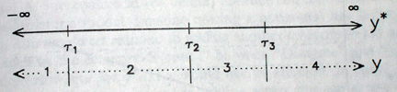
Then, our regression model of latent Y on X is assumed to look like this (you can see how the categories are mapped onto the latent variable – they are not equal).
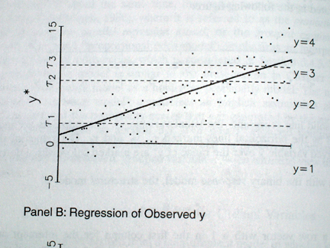

This is one interpretation of ordered logit model. Another one is that it combines a set of binary logits by constraining them to be the same equation. We could estimate binary logit models for each category to predict probability of belonging to that group or any group below it. We could then require all of these logits to have the same slopes and we could estimate them simultaneously – the result is the ordered logit model. To understand why they have to be the same (this is called parallel slopes assumption), we can return to our latent Y model – the slope of the line is the same across all categories – for the entire span of the latent variable. That is how this assumption looks when we examine probabilities:

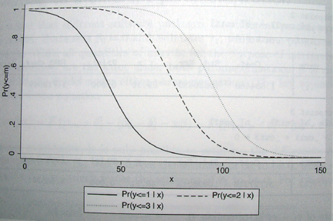

We’ll use a subset of longitudinal data from the Health and Retirement Study (hrs_hours_reshaped.dta) and predict hours of work based on hours spent helping one’s parents as well as various controls. We will recode hours of work into 4 categories for this example. I will right away estimate a model with odds ratios.

. recode rworkhours80 (0=0) (1/30=1) (31/50=2) (51/80=3), gen(rworkhours4)
(23290 differences between rworkhours80 and rworkhours4)

. meologit rworkhours4 rpoorhealth rmarried rtotalpar rsiblog hchildlg rallparhelptw female raedyrs age minority || hhidpn: rpoorhealth , or

Mixed-effects ologit regression Number of obs = 30,541
Group variable: hhidpn Number of groups = 6,243

Obs per group:
min = 1
avg = 4.9
max = 9

Integration method: mvaghermite Integration pts. = 7

Wald chi2(10) = 2886.84
Log likelihood = -29889.765 Prob > chi2 = 0.0000
----------------------------------------------------------------------------------
rworkhours4 | Odds Ratio Std. Err. z P>|z| [95% Conf. Interval]
-----------------+----------------------------------------------------------------
rpoorhealth | .2024437 .0142883 -22.63 0.000 .1762897 .2324778
rmarried | .7595365 .0495799 -4.21 0.000 .6683211 .8632014
rtotalpar | 2.472556 .0587662 38.09 0.000 2.360018 2.59046
rsiblog | 1.092916 .0567357 1.71 0.087 .9871859 1.20997
hchildlg | .8388503 .046101 -3.20 0.001 .7531903 .9342524
rallparhelptw | .9464933 .0038434 -13.54 0.000 .9389902 .9540563
female | .2541045 .0169547 -20.53 0.000 .2229551 .2896058
raedyrs | 1.108991 .0129775 8.84 0.000 1.083845 1.13472
age | .8665796 .0093365 -13.29 0.000 .8484722 .8850735
minority | 1.020861 .0821003 0.26 0.797 .8719888 1.195151
-----------------+----------------------------------------------------------------
/cut1 | -7.457429 .642393 -8.716496 -6.198362
/cut2 | -6.453125 .6418843 -7.711196 -5.195055
/cut3 | -2.937608 .6407136 -4.193384 -1.681833
-----------------+----------------------------------------------------------------
hhidpn |
var(rpoorhealth)| 2.840702 .3109701 2.292161 3.520516
var(_cons)| 4.743435 .1555185 4.448212 5.058252
----------------------------------------------------------------------------------
Note: Estimates are transformed only in the first equation.
LR test vs. ologit model: chi2(2) = 8925.32 Prob > chi2 = 0.0000

Note: LR test is conservative and provided only for reference.

Briefly, the odds ratios for ordered logit are cumulative odds of belonging to a certain category or lower versus belonging to one of the higher categories. For example, if our dependent variable is the level of agreement with some statement and the categories are agree=3, not sure=2, and disagree=1, and if the odds ratio for gender as a predictor of that agreement is 2.00, we can say that the odds of disagreeing rather than agreeing or being not sure are 2 times higher for women than for men. Similarly, the odds of disagreeing or being not sure are also twice as high for women than for men.

What this means is that ologit assumes that these two odds ratios are essentially the same and thus uses the average. That is called the parallel slopes assumption. So we are assuming these two odds ratios are the same – if they differ significantly, the assumption is violated.

Stata does not provide diagnostic tools for panel data for testing the parallel slopes assumption, so in order to obtain a rough test, you might want to run your model without taking panel nature of the data into account (using regular ologit command) and test that assumption that way, even though such a test will be approximate. Another way to do so would be to create the corresponding dichotomies (here, rworkhours4=1 vs 2 3 4, rworkhours4= 1 2 vs 3 4, and rworkhours4=1 2 3 vs 4) and estimate models separately for each dichotomy using melogit – we can then examine whether odds ratios indeed look similar in such models (that’s what parallel slopes assumption presumes).

To interpret coefficients here, for example, if a respondent reports poor health, their odds of working full time or overtime are almost 80% lower.

Multinomial Logit

We use multinomial logit models when we have multiple categories but cannot order them (or we can, but the parallel regression assumption does not hold). Here the order of categories is unimportant. Multinomial logit model is equivalent to simultaneous estimation of multiple logits where each of the categories is compared to one selected so-called base category. But if we would estimate them separately, we would lose information, as each logit would be estimated on a different sample (selected category plus base category, with all other categories omitted from analyses). To avoid that, we use multinomial logit.

Multinomial logit does not assume parallel slopes – so if we estimate it for ordinal level variable and then plot cumulative probabilities, we would see something like this (note the variation in slope!):

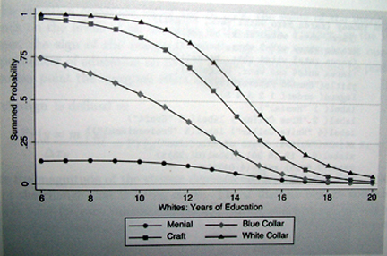

The best way to estimate a random effects multinomial logit in Stata is using SEM module, and specifically gsem command with mlogit option. You can either specify a version estimating a single random effect or a separate random effect for each equation (we have m-1 equations in multinomial logit with m alternatives). The second option is less restrictive and usually preferred. Here is an example using rworkhours4 we generated above (its values are 0 -3).
We can either use model builder to build the following GSEM model, or enter a command:
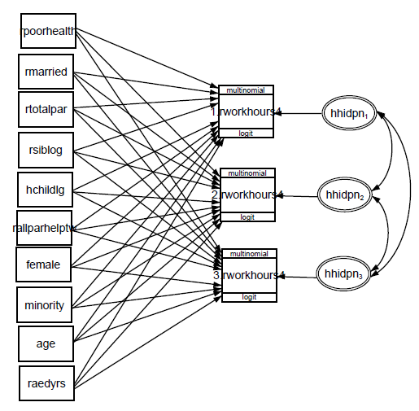

. gsem (1.rworkhours4 <- rpoorhealth rmarried rtotalpar rsiblog hchildlg rallparhelptw female raedyrs age minority M1[hhidpn]) (2.rworkhours4 <- rpoorhealth rmarried rtotalpar rsiblog hchildlg rallparhelptw female raedyrs age minority M2[hhidpn]) (3.rworkhours4 <- rpoorhealth rmarried rtotalpar rsiblog hchildlg rallparhelptw female raedyrs age minority M3[hhidpn]), mlogit

Generalized structural equation model Number of obs = 30541
Log likelihood = -27850.963

( 1) [1.rworkhours4]M1[hhidpn] = 1
( 2) [2.rworkhours4]M2[hhidpn] = 1
( 3) [3.rworkhours4]M3[hhidpn] = 1
----------------------------------------------------------------------------------
| Coef. Std. Err. z P>|z| [95% Conf. Interval]
-----------------+----------------------------------------------------------------
0.rworkhours4 | (base outcome)
-----------------+----------------------------------------------------------------
1.rworkhours4 <- |
rpoorhealth | -1.277058 .0828982 -15.41 0.000 -1.439536 -1.114581
rmarried | -.0611107 .1034527 -0.59 0.555 -.2638743 .141653
rtotalpar | .7099914 .0435582 16.30 0.000 .6246189 .7953638
rsiblog | .1661102 .077469 2.14 0.032 .0142738 .3179466
hchildlg | -.096628 .0827913 -1.17 0.243 -.2588961 .06564
rallparhelptw | -.0141175 .0064669 -2.18 0.029 -.0267924 -.0014426
female | -.1735534 .0970918 -1.79 0.074 -.3638498 .016743
raedyrs | .1371333 .0171756 7.98 0.000 .1034697 .1707969
age | -.0867121 .0155403 -5.58 0.000 -.1171705 -.0562537
minority | -.0228635 .116838 -0.20 0.845 -.2518618 .2061348
|
M1[hhidpn] | 1 (constrained)
|
_cons | .9628375 .9322679 1.03 0.302 -.864374 2.790049
-----------------+----------------------------------------------------------------
2.rworkhours4 <- |
rpoorhealth | -1.750017 .0704374 -24.85 0.000 -1.888072 -1.611963
rmarried | -.4516769 .0962687 -4.69 0.000 -.6403599 -.2629938
rtotalpar | 1.442584 .0412238 34.99 0.000 1.361786 1.523381
rsiblog | .1445202 .0763168 1.89 0.058 -.0050579 .2940982
hchildlg | -.3232379 .080663 -4.01 0.000 -.4813346 -.1651413
rallparhelptw | -.0809335 .0061454 -13.17 0.000 -.0929784 -.0688887
female | -1.543764 .1004039 -15.38 0.000 -1.740552 -1.346976
raedyrs | .130158 .017173 7.58 0.000 .0964996 .1638165
age | -.2034751 .0160609 -12.67 0.000 -.2349538 -.1719963
minority | .1211653 .1181552 1.03 0.305 -.1104146 .3527453
|
M2[hhidpn] | 1 (constrained)
|
_cons | 9.600093 .9520152 10.08 0.000 7.734177 11.46601
-----------------+----------------------------------------------------------------
3.rworkhours4 <- |
rpoorhealth | -1.916659 .1124895 -17.04 0.000 -2.137134 -1.696184
rmarried | -.5334537 .1407739 -3.79 0.000 -.8093655 -.2575419
rtotalpar | 1.748915 .0562372 31.10 0.000 1.638692 1.859137
rsiblog | .2218076 .1072693 2.07 0.039 .0115636 .4320515
hchildlg | -.2066806 .1144466 -1.81 0.071 -.4309919 .0176307
rallparhelptw | -.1073193 .0103503 -10.37 0.000 -.1276055 -.0870331
female | -2.875229 .1459855 -19.70 0.000 -3.161355 -2.589102
raedyrs | .2372999 .0241533 9.82 0.000 .1899602 .2846395
age | -.2478874 .0225544 -10.99 0.000 -.2920931 -.2036816
minority | -.0932506 .166257 -0.56 0.575 -.4191083 .2326072
|
M3[hhidpn] | 1 (constrained)
|
_cons | 8.004163 1.330828 6.01 0.000 5.395788 10.61254
-----------------+----------------------------------------------------------------
var(M1[hhidpn])| 7.277483 .3634233 6.598935 8.025803
var(M2[hhidpn])| 10.11641 .4346091 9.299468 11.00512
var(M3[hhidpn])| 16.62133 .7747086 15.17022 18.21125
-----------------+----------------------------------------------------------------
cov(M2[hhidpn],|
M1[hhidpn])| 5.774199 .324637 17.79 0.000 5.137922 6.410476
cov(M3[hhidpn],|
M1[hhidpn])| 6.872237 .41161 16.70 0.000 6.065496 7.678978
cov(M3[hhidpn],|
M2[hhidpn])| 10.77613 .50847 21.19 0.000 9.779549 11.77272
----------------------------------------------------------------------------------

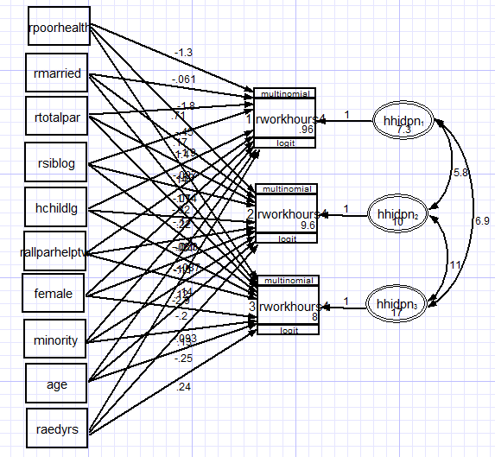
You would need to exponentiate coefficients to get odds ratios. Note that variables predict the membership in each group as compared to membership in the omitted group (rworkgroup4=0), so you can interpret odds ratios as the effect of a given predictor on the odds of being in a given group vs in the omitted group.

. est store gsem

. est table gsem, eform star b(%4.3f)

-----------------------------
Variable | gsem
-------------+---------------
0b.rworkho~4 |
_cons | (omitted)
-------------+---------------
1.rworkhou~4 |
rpoorhealth | 0.279***
rmarried | 0.941
rtotalpar | 2.034***
rsiblog | 1.181*
hchildlg | 0.908
rallparhel~w | 0.986*
female | 0.841
raedyrs | 1.147***
age | 0.917***
minority | 0.977
|
M1[hhidpn] | 2.718
|
_cons | 2.619
-------------+---------------
2.rworkhou~4 |
rpoorhealth | 0.174***
rmarried | 0.637***
rtotalpar | 4.232***
rsiblog | 1.155
hchildlg | 0.724***
rallparhel~w | 0.922***
female | 0.214***
raedyrs | 1.139***
age | 0.816***
minority | 1.129
|
M2[hhidpn] | 2.718
|
_cons | 1.5e+04***
-------------+---------------
3.rworkhou~4 |
rpoorhealth | 0.147***
rmarried | 0.587***
rtotalpar | 5.748***
rsiblog | 1.248*
hchildlg | 0.813
rallparhel~w | 0.898***
female | 0.056***
raedyrs | 1.268***
age | 0.780***
minority | 0.911
|
M3[hhidpn] | 2.718
|
_cons | 2993.395***
-------------+---------------
var( |
M1[hhidpn])| 1447.340***
var( |
M2[hhidpn])| 2.5e+04***
var( |
M3[hhidpn])| 1.7e+07***
cov( |
M1[hhidpn],|
M2[hhidpn])| 321.886***
cov( |
M1[hhidpn],|
M3[hhidpn])| 965.105***
cov( |
M2[hhidpn],|
M3[hhidpn])| 4.8e+04***
-----------------------------
legend: * p<0.05; ** p<0.01; *** p<0.001

So for example, the odds of working part time rather than not working are 72.1% lower for those in poor health than for those in good health, while the odds of working full time rather than not working are 82.6% lower and the odds of working overtime rather than not working are 85.3% lower for the same health comparison.

To further complicate this model and allow for random slopes, you need to introduce even more latent variables with hhidpn in them and have these variables interact with those predictors for which you want to have random slopes. In terms of syntax, it looks like this:

gsem (1.rworkhours4 <- rpoorhealth rmarried rtotalpar rsiblog hchildlg rallparhelptw female raedyrs age minority M1[hhidpn] 1.rpoorhealth#M2[hhidpn]) (2.rworkhours4 <- rpoorhealth rmarried rtotalpar rsiblog hchildlg rallparhelptw female raedyrs age minority M3[hhidpn] 1.rpoorhealth#M4[hhidpn]) (3.rworkhours4 <- rpoorhealth rmarried rtotalpar rsiblog hchildlg rallparhelptw female raedyrs age minority M5[hhidpn] 1.rpoorhealth#M6[hhidpn]), mlogit

For a simpler case, a diagram would look like this:

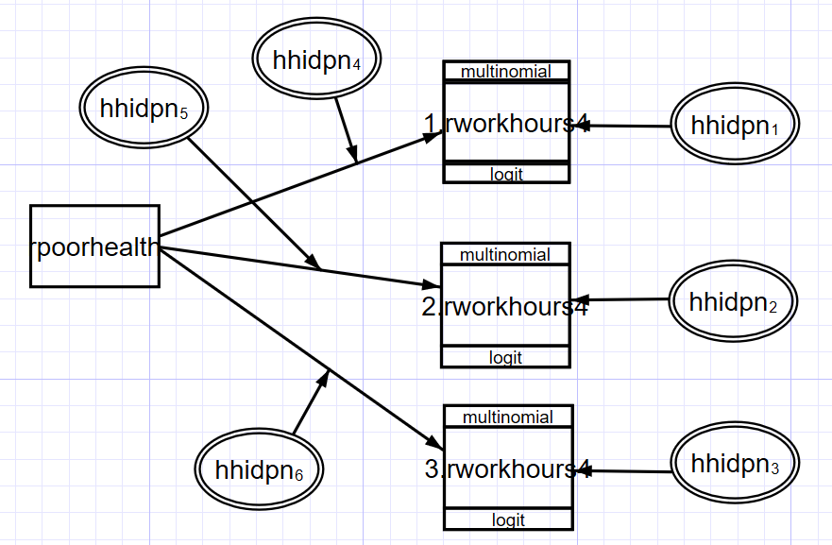

These kinds of models tend to estimate very slowly, and you may need to deal with convergence issues – see intro 12 at https://www.stata.com/manuals/sem.pdf

Count data models

Count variables are often treated as though they are continuous, and regular regression is used, but it can result in inefficient, inconsistent, and biased estimates. Need to use models that are developed specifically for count data. Poisson model is the most basic of them.

Characteristics of Poisson distribution:
1. E(y) = μ
2. The variance equals the mean: Var(y)=E(y)= μ -- equidispersion. In practice, the variance is often larger than μ: this is called overdispersion. The main reason for overdispersion is heterogeneity – if there are different groups within data that have different means and all of them are actually equal to their variances, when you put all of these groups together, the resulting combination will have variance larger than the mean. Therefore, we need to control for all those sources of heterogeneity. Thus, when using Poisson regression, we need to ensure that the conditional variance equals to the mean – that is Var(y|X)=E(y|X).
3. As μ increases, the probability of zeros decreases. But for many count variables, there are more observed zeros than would be predicted from Poisson distribution
4. As μ increases, the Poisson distribution approximates normal.
5. The assumption of independence of events – past outcomes don’t affect future outcomes.

Poisson distributions:

Luckily, we can estimate a mixed effects Poisson model or negative binomial model. Let’s examine an example of mixed Poisson model (there is also a corresponding negative binomial regression command, menbreg):

. mepoisson rworkhours80 rpoorhealth rmarried rtotalpar rsiblog hchildlg rallparhelptw female raedyrs age minority || hhidpn:

Mixed-effects Poisson regression Number of obs = 30541
Group variable: hhidpn Number of groups = 6243

Obs per group: min = 1
avg = 4.9
max = 9

Integration points = 7 Wald chi2(10) = 30723.86
Log likelihood = -237592.87 Prob > chi2 = 0.0000

------------------------------------------------------------------------------
rworkhours80 | Coef. Std. Err. z P>|z| [95% Conf. Interval]
-------------+----------------------------------------------------------------
rpoorhealth | -.317193 .0052424 -60.50 0.000 -.327468 -.3069181
rmarried | -.0465037 .0082793 -5.62 0.000 -.0627308 -.0302767
rtotalpar | .3166688 .0022498 140.75 0.000 .3122593 .3210784
rsiblog | .1548763 .0113293 13.67 0.000 .1326713 .1770813
hchildlg | -.1326281 .010343 -12.82 0.000 -.1529001 -.1123561
rallparhel~w | -.0194976 .0004307 -45.27 0.000 -.0203418 -.0186534
female | -1.088872 .0594299 -18.32 0.000 -1.205353 -.972392
raedyrs | .1293615 .009998 12.94 0.000 .1097657 .1489573
age | -.1223611 .0096613 -12.67 0.000 -.141297 -.1034253
minority | -.1271817 .0701653 -1.81 0.070 -.2647031 .0103396
_cons | 7.385015 .5605793 13.17 0.000 6.2863 8.483731
------------------------------------------------------------------------------

------------------------------------------------------------------------------
Random-effects Parameters | Estimate Std. Err. [95% Conf. Interval]
-----------------------------+------------------------------------------------
hhidpn: Identity |
sd(_cons) | 2.247979 .0274216 2.194871 2.302372
------------------------------------------------------------------------------
LR test vs. Poisson regression: chibar2(01) = 3.9e+05 Prob>=chibar2 = 0.0000

With regular coefficients presented here, we can interpret sign and significance, but to interpret the size, we exponentiate the coefficients – these are called incidence rate ratios. They are also multiplicative coefficients, like odds ratios, and can be interpreted as percent change in the number of events.

. mepoisson rworkhours80 rpoorhealth rmarried rtotalpar rsiblog hchildlg rallparhelptw female raedyrs age minority || hhidpn:, irr

Mixed-effects Poisson regression Number of obs = 30,541
Group variable: hhidpn Number of groups = 6,243

Obs per group:
min = 1
avg = 4.9
max = 9

Integration method: mvaghermite Integration pts. = 7

Wald chi2(10) = 30835.46
Log likelihood = -237571.3 Prob > chi2 = 0.0000
------------------------------------------------------------------------------
rworkhours80 | IRR Std. Err. z P>|z| [95% Conf. Interval]
-------------+----------------------------------------------------------------
rpoorhealth | .7282366 .0038166 -60.51 0.000 .7207944 .7357557
rmarried | .9545705 .0078981 -5.62 0.000 .9392154 .9701767
rtotalpar | 1.372556 .0030877 140.77 0.000 1.366517 1.378621
rsiblog | 1.16752 .0131903 13.71 0.000 1.141952 1.193661
hchildlg | .8757708 .0090403 -12.85 0.000 .8582302 .8936699
rallparhel~w | .9806913 .0004224 -45.27 0.000 .9798638 .9815195
female | .3359979 .0189861 -19.30 0.000 .3007725 .3753487
raedyrs | 1.138186 .0107564 13.70 0.000 1.117298 1.159464
age | .8847575 .0080896 -13.39 0.000 .8690434 .9007556
minority | .8809494 .0585982 -1.91 0.057 .7732706 1.003623
_cons | 1610.439 855.6806 13.90 0.000 568.424 4562.642
-------------+----------------------------------------------------------------
hhidpn |
var(_cons)| 5.119811 .1233827 4.883608 5.367439
------------------------------------------------------------------------------
Note: Estimates are transformed only in the first equation.
Note: _cons estimates baseline incidence rate (conditional on zero random
effects).
LR test vs. Poisson model: chibar2(01) = 3.9e+05 Prob >= chibar2 = 0.0000

So for example, if the respondent is currently married, they work 4.5% fewer hours than if they are not married. Each extra year of education increases the number of hours worked by 14%.

In practice, Poisson regression model rarely fits due to overdispersion. One key process that often creates overdispersion is known as contagion – violation of the assumption of the independence of events. This assumption is often unrealistic; e.g. if you have your first child, that increases your chances of having your second.

To better model overdispersion from this and other sources, we can use negative binomial model. It allows taking into account unobserved heterogeneity. To do so, it introduces an additional parameter – alpha, known as the dispersion parameter. Increasing alpha increases the conditional variance of our count variable. If alpha is zero, the model becomes regular Poisson model.

. menbreg rworkhours80 rpoorhealth rmarried rtotalpar rsiblog hchildlg rallparhelptw female raedyrs age minority || hhidpn:, irr

Mixed-effects nbinomial regression Number of obs = 30,541
Overdispersion: mean
Group variable: hhidpn Number of groups = 6,243

Obs per group:
min = 1
avg = 4.9
max = 9

Integration method: mvaghermite Integration pts. = 7

Wald chi2(10) = 2400.45
Log likelihood = -110234.72 Prob > chi2 = 0.0000
------------------------------------------------------------------------------
rworkhours80 | IRR Std. Err. z P>|z| [95% Conf. Interval]
-------------+----------------------------------------------------------------
rpoorhealth | .4204695 .0156794 -23.23 0.000 .3908346 .4523515
rmarried | .8480047 .0445282 -3.14 0.002 .7650718 .9399274
rtotalpar | 1.671643 .0306495 28.02 0.000 1.612638 1.732808
rsiblog | 1.124322 .0469158 2.81 0.005 1.036028 1.22014
hchildlg | .8842482 .0392321 -2.77 0.006 .8106031 .9645841
rallparhel~w | .9687546 .0030539 -10.07 0.000 .9627874 .9747587
female | .3541711 .019064 -19.28 0.000 .3187098 .3935779
raedyrs | 1.106181 .0103088 10.83 0.000 1.086159 1.126571
age | .8974593 .0078051 -12.44 0.000 .8822911 .9128882
minority | 1.002555 .0645823 0.04 0.968 .8836405 1.137472
_cons | 1431.585 739.6125 14.07 0.000 520.06 3940.769
-------------+----------------------------------------------------------------
/lnalpha | .8295796 .0117374 .8065748 .8525844
-------------+----------------------------------------------------------------
hhidpn |
var(_cons)| 3.850327 .1192165 3.623615 4.091222
------------------------------------------------------------------------------
Note: Estimates are transformed only in the first equation.
Note: _cons estimates baseline incidence rate (conditional on zero random
effects).
LR test vs. nbinomial model: chibar2(01) = 2030.20 Prob >= chibar2 = 0.0000

The extra parameter here, expressed as logarithm alpha, is clearly different from 0 (based on the confidence interval), so this model would be preferable over poisson. Of course, we can still explore random slopes and cross-level interactions, etc.

Overall, some of the same concerns apply here as was the case for logistic regression – for instance, we have to be cautious when interpreting interactions and examine predicted counts.
In terms of variance, the level 1 residuals variance, which we assumed to be 3.29 in logit-based models, is assumed to be equal to predicted mean, so you need to find the value of average predicted count by generating predicted values, exponentiating them, and calculating their mean. You can use that number as level 1 variance in the formulas for percent of variance explained discussed above as well as when calculating the intraclass correlation coefficient.

